**UNIPER**

**Azure Devops**

**RUN BOOK (Draft Version)**

**Version Control**

(To be filled by Technology Office Service Owners)

|  |  |  |  |  |  |  |  |
| --- | --- | --- | --- | --- | --- | --- | --- |
| **Sl. No.** | **Tower(s)** | **Run book Owner** | **Date of Revision** | **Reviewed By** | **Changes Made** | **Approved By** | **Version** |
| **1** | **Azure Devops** | Vamshi / Ashok | 03-05-2022 |  |  |  | 1.0 |

Table of Contents

**1.** Introduction………………………………………………………………………………………………………………………..………………3

**1.1** Purpose ……………………………………………………………………………………………………………………………………………3

**1.2** Document Scope 3

**1.2.1** What this document covers 3

**1.2.** What this document does not cover 4

**1.2.3** Usage Expectations 4

**2.** Contact Information 4

**2.1** Vendor Details 4

**3.** High-level Overview of Azure DevOps Team 5

**4.** Azure DevOps Uniper Landscape 6

**5.** DevOps - Add (free) extension from Marketplace to Azure DevOps Account 7

**5.1** **Process Artifact’s……………………………………………………………………………………………………………………………7**

**5.2** Key Satakeholder……………………………………………………………………………………………………………………………….8

**5.3** Input Requirements8

**5.4** Output Documents…………………………………………………………………………………………………………………………….8

**5.5** Lead Times, KPI's, Cycle Times8

**5.6** Reporting8

**5.7** Ordering of Service Request8

**5.8** High Level process view - Add (free) extension from Marketplace to Azure DevOps Account 9

**6.** Azure DevOps Organization Overview9

**7.** projects10

**8.** Users10

**9.** Agents 11

**10.** Cost distribution11

**11.** Azure Devops Billing12

**12.** Extensions12

**13.** Auditing13

**14.** Permissions14

**15**. Create Project…………………………………………………………………………………………………………………………………..14

**16.** process…………………………………………………………………………………………………………………………………………….16

**17.** Agent Pools………………………………………………………………………………………………………………………………………17

**18.** Process of Raising Selfhosted Agent Request……………………………………………………………………………………17

**19.** Service Connections…………………………………………………………………………………………………………………………18

**20.** Automation Scripts………………………………………………………………………………………………………………………....19

**21.** SonarCloud………………………………………………………………………………………………………………………………………20

**22.** Create and Delete Project in SonarCloud……………………………………………………………………………………….…21

**23.** Onboard user/Group in SonarCloud………………………………………………………………………………………………...23

**24.** Adding Users to the Groups in SonarCloud………………………………………………………………………………………24

**25.** Service Connection to SonarCloud……………………………………………………………………………………………………25

**26.** Azure Devops and SonarCloud Integration……………………………………………………………………………………....28

**27.** CMC Managed Containers…………………………………………………………………………………………………………….….28

**28.** Logic App………………………………………………………………………………………………………………………………………….28

**28.1** License Remainder……………………………………………………………………………………………………………………..….28

**28.2** Audit log backup…………………………………………………………………………………………………………………….………29

**29.** Logic App User Task………………………………………………………………………………………………………………………….31

**30.** Repositories……………………………………………………………………………………………………………………..………………32

**30.1** GitHub………………………………………………………………………………………………………………………………….………..32

**30.2** Wiki Documents…………………………………………………………………………………………………………………….……….34

**30.3** Azure Devops Demogenerator……………………………………………………………….………………………………………34

**31.** Storage Tables……………………………………………………………………………………………….…………………………………36

**32.** ACR Task……………………………………………………………………………………………………………………………………….….38

**33.** GitHub Runner…………………………………………………………………………………………………………………………………40

**34.** Terminologies in GitHub runner………………………………………………………………………………………………………40

**34.1** Events……………………………………………………………………………………………………………………………..…………….40

**34.2** Jobs……………………………………………………..………………………………………………………………………………………..41

**34.3** Environment Variables……………………………………………………………………………………………………..……………41

**35.** Reference Links………………………………………………………………………………………………………………………………..42

**36.** Azure Devops Shadowing Sessions……………………………………………………………………………………………………44

**37.** Create New Project in Agile Methodology………………………………………………………………………………………..44

**38.** Service connection Creation for user requested project: ex; project name is “Dynamic Dalsy - streaming” & resource group………………………………………………………………………………………………………………...49

**39.** NameSpace creation for Project………………………………………………………………………………..…………..………..54

**40.** Extensions………………………………………………………………………………………………………………………………..….....58

# Introduction

## Purpose

This Run Book is a routine compilation of procedures and operations that the system administrator or operator carries out. It contains procedures to begin, stop, supervise, and debug the system. It may also describe procedures for handling special requests and contingencies.

This run book serves as a production guide that encompasses all infrastructure components of the Azure Devops, it also provides escalation contacts and procedures for obtaining Technical Support from the product vendor. Additionally, it provides various system reference tools and convenient links to websites where further product information, patches, and updates release notes can be found. It is intended for use by the CIS Delivery groups.

Please Visit the below link for all the Latest Run books.

[link](https://cgi.cognizant.com/bu/ITIS/Pages/Capability/Runbooks.aspx#k=) to update

Cognizant Infrastructure Services Practice provides customers with a portfolio of services designed to meet their needs. These services are based on industry recognized “best-practices’ and utilize acknowledged industry standards, such as ITIL and ITIL-based practices.

## Document Scope

### What this document covers

The purpose of this Run Book is to provide daily activities required to support the service at an operations or procedural level.

* Contact Information (Team, Customer, Vendor, Crisis & escalation)
* Inventory Information
* ITIL Process Related Information
* Task list executed by Support Levels
* Product/Technology Related Information
* References
* Annexure

### What this document does not cover

This Run book does not cover

* Passwords/Confidential Information
* Reporting Mechanism
* Shift Roster
* Resource Plan

### Usage Expectations

Operation Teams will use this Document to support routine procedures and operations, in addition to handling special requests and contingencies. This Run Book should be updated by **HaCT Windows team** with any future scope changes.

# Contact Information

Contact List from Uniper Wiki - [Here](https://wiki.intranet.uniper.energy/sales/display/CF/Contact+list)

**3. High-level Overview of Azure DevOps Team:**

* We are primary contact for entire DevOps Services.
* We have specific work categorized here.
* Here we will onboard their projects into infrastructure, based on their requirement we will configure the projects.
* Once project is created and appropriate access was granted, we will not be responsible for managing anything going ahead. We can help them, but we will not manage them.
* Means, once project created, they will create their repos, they will setup their branch policies, they will push their code into repos. Creating pipeline and setting up test planes. They do everything them self.
* In case of any configurational issues, any help they are seeking. They will get back to us. We need to help them.
* We should stick to our architecture. We will guide them how should it to be done.

**4. Azure DevOps Uniper Landscape:**

* The Azure DevOps Development Platform is a Microsoft SaaS offering that can be accessed via browser after authentication to the Azure Active Directory.
* The main integration of developer workstations with Azure DevOps is the source code management system in Azure DevOps (Git).
* Each project in Azure DevOps can contain one or several Git repositories that are managed by the project administrator.

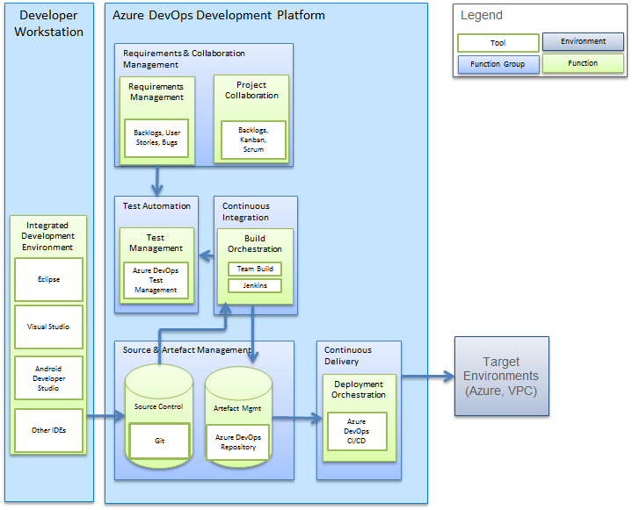

**5. DevOps - Add (free) extension from Marketplace to Azure DevOps Account:**

* Goal of this service is to install free extension into Azure DevOps Uniper production account from <https://marketplace.visualstudio.com/azuredevops> based on Azure DevOps Project Administrator request.
  1. **Process Artifact’s**

•Request raised via ServiceNow [catalogue](https://uniperprod.service-now.com/unipersp?id=sc_cat_item_uni&sys_id=725653dadbf82c10d1ebbaf1f39619bf)  
•Request approval from Line Manager  
•Approval or rejection from IT Security  
•Approval or rejection from Enterprise Azure DevOps Architecture team  
•ServiceNow comment Notification email will be sent to requester about extension installation and request completion

* 1. **Key Stakeholder**

•Development team (Requester)  
•HACT Development team  
•Line Manager  
•Security Team  
•Enterprise Azure DevOps Architecture team  
• Project Administrator

→ You can see list of all stakeholder participants and their responsibility [*here*](https://wiki.intranet.uniper.energy/sales/display/CF/Participants+and+Responsibilities+of+HACT+Managed+Service+Request)

* 1. **Input Requirements**

•Requested for (Name will be auto filled)  
•Line manager (Name will be auto filled)  
•Name of extension from the Market place  
•Additional Contact Information (If any)  
• Additional Information (EX: URL of extension or specific version of extension etc.)

* 1. **Output Documents**

• HACT development team will add comment to ServiceNow request and change status to review pending with requester. Based on it ServiceNow will trigger email about request completion and review.

* 1. **Lead Times, KPI’s, Cycle Times**

• After receiving the request and all requirements are met, the HACT Development team will require twenty business days to complete the request.

* 1. **Reporting**

• You can find last 12 month of SNOW request Here raised in below two-assignment group managed by HACT Development Team.

1. UNI-HaCT-DEV-Support
2. uni-hact-azuredevopslicense-support
   1. **Ordering of Service Request**

• This service can be ordered via ServiceNow [catalogue](https://uniperprod.service-now.com/unipersp?id=sc_cat_item_uni&sys_id=725653dadbf82c10d1ebbaf1f39619bf)

* 1. **High Level process view - Add (free) extension from Marketplace to Azure DevOps Account**

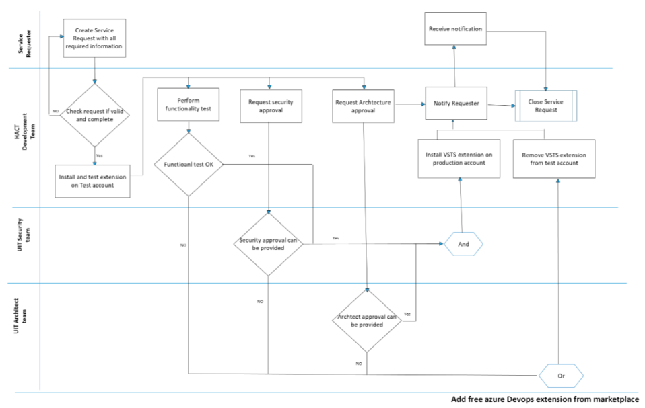

**6. Azure DevOps Organization Overview:**

* Here we will manage two oraganizations.

**1.Uniperteamservices** is main organization which is used by user.  
**2. Unipettestaccount** this for our R&D.

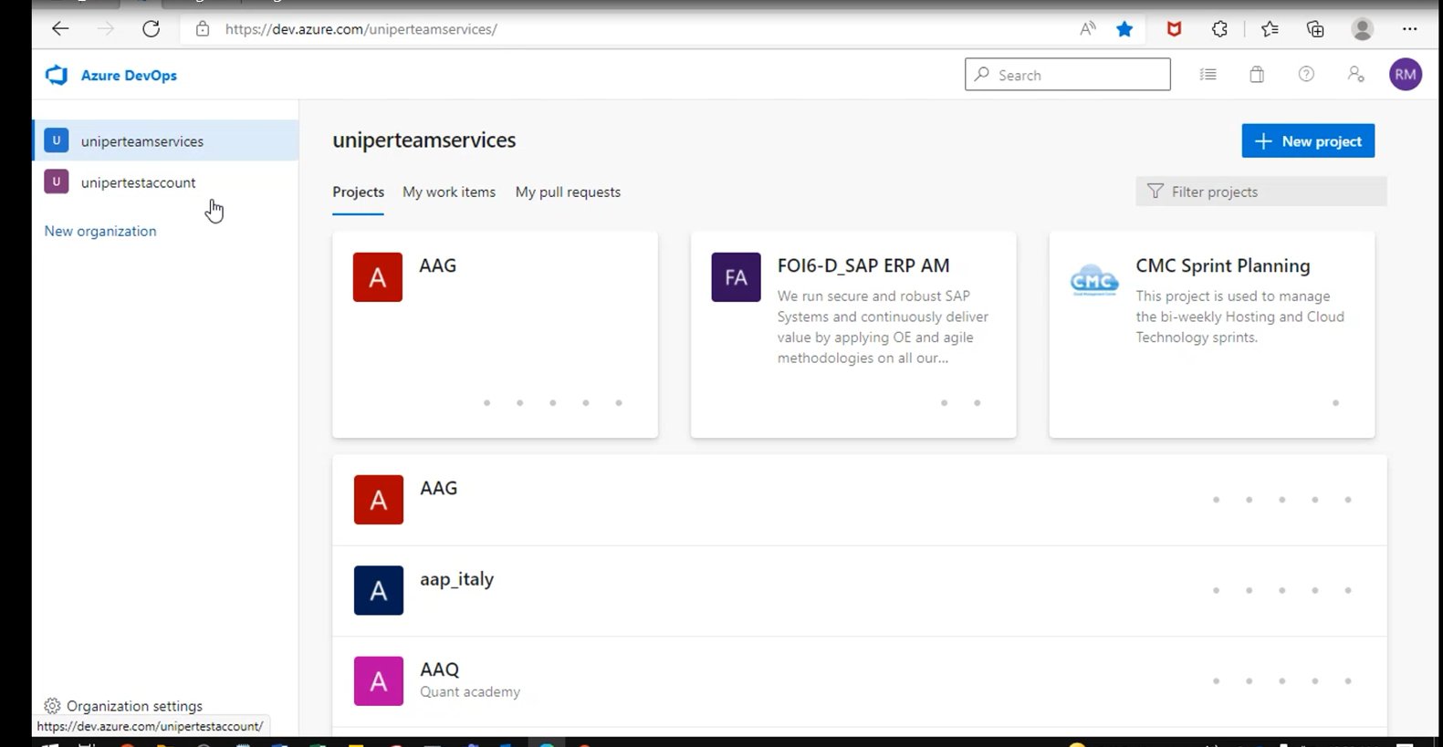

**7. Projects:**

* We have around 500 projects, but we don’t have access to all projects. One set of business unit they don’t want to see their code to external people like CTS, Wipro.
* Project Administrator have authority to remove user access to that project.

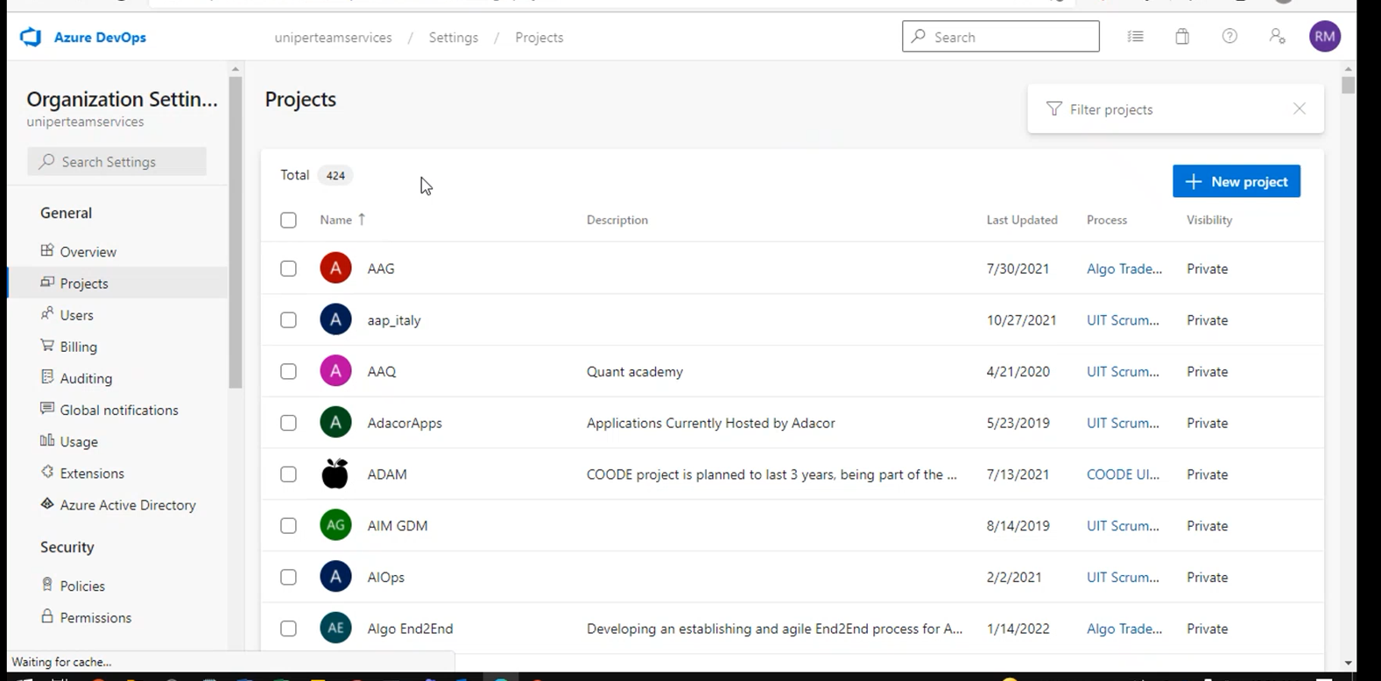

**8. Users:**

* Users have two license types: Basic and Stakeholder. The Stakeholder license is free and can be used for non-developer tasks (e.g. reviewing a Kanban board or release approval). If users have already a Visual Studio license (Professional or Enterprise) this includes already Azure DevOps Basic license (provided the Visual Studio license is linked to the account that the user is using in Azure DevOps). A basic user license is currently at about 5 EUR/month.
* We have around 2097 users.
* Users will raise Service now request for Basic and stakeholder level access not for test planes.
* Users will raise request from snow Catalogue, once request approved, license will automatically add into ado organization. For test planes Carsten need to approve it and need to assign.
* If users want test plane access, we need to ask them for justification email by looping project admin.
* License provisioning done by Carsten.

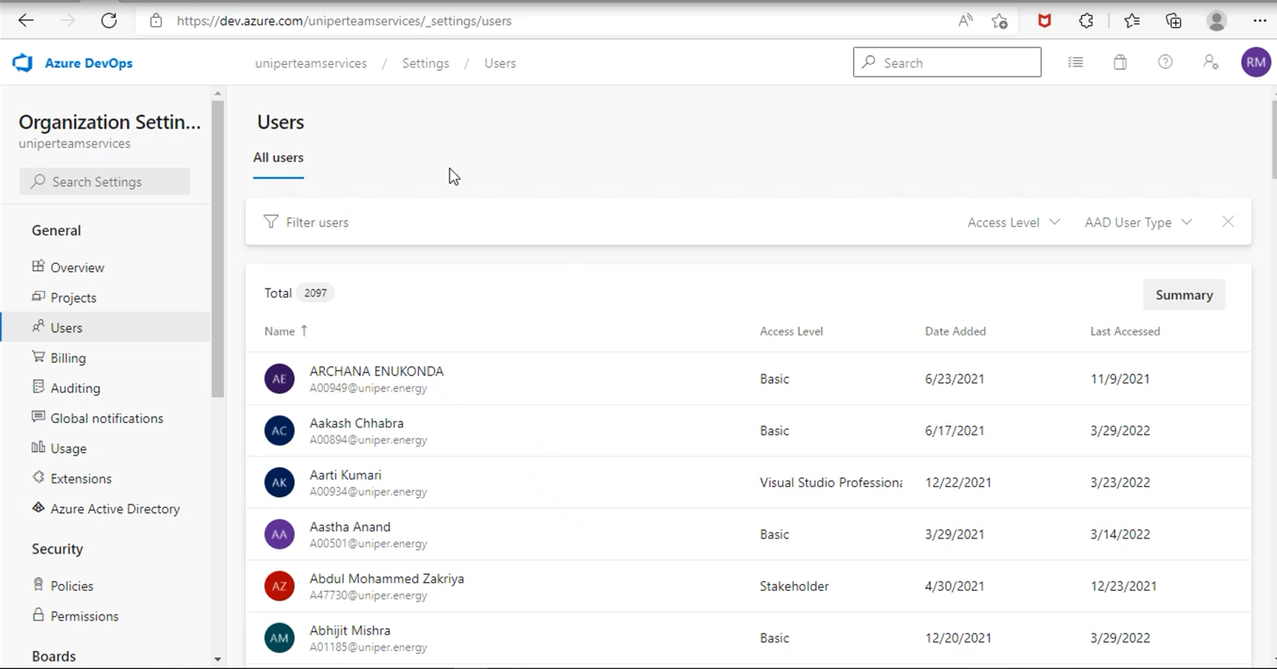

**9. Agents:**

Dedicated agents might be requested by a project team. These agents can either be set up in a private/public cloud or be added to the agent pool in Azure DevOps. Agents in the private/public cloud are free of charge in Azure DevOps (but of course create some costs for the VM in the specific cloud). Agents in the Azure DevOps pool are covered by [HaCT](https://wiki.intranet.uniper.energy/sales/pages/viewpage.action?pageId=45089074).

### **10. Cost distribution**:

All costs of the Uniper Azure DevOps account are linked to an Azure Subscription (in a specific Resource Group). The costs for user licenses and extensions are charged back to differents customers (LOBs) based on the assignment of each user. The costs for consumed Cloud resources (including agents) are assigned to projects via a corresponding cost code.

**11. Azure DevOps Billing:**

* Billing is managed by central team. We need to give license wisely. if we have 10 members in a team, no need to give basic+ test plan license to everyone. Because it will cost highly. If it is one or two request that is fine.
* We will get entire billing for one subscription, that will manage by Carsten (Owner).
* Azure DevOps is a cost-effective development platform based on a subscription model. The following cost types exist:

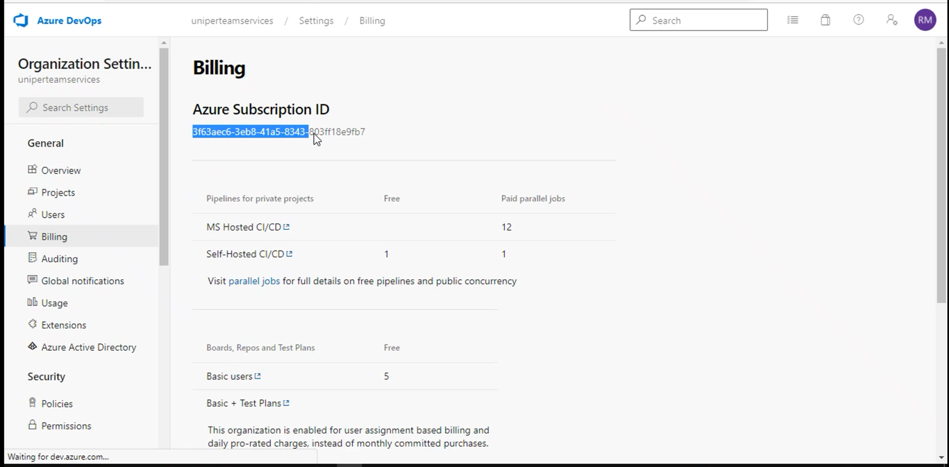

**12. Extensions:**

* Users will raise request from snow for to install extensions. Before installing it will go to certain levels of checks and verification to avoid compliance and security breach.
* Once we get the request, we will inform to Carsten, he will check the extension whether it is from trusted organization or not, do we have any similar type of extension.
* He will verify with IT security team. Once get the feedback from IT security team. Carsten will install this extension.
* We need to clean up unused and deprecated extensions time to time. We need to check for new one in place of deprecated one.
* This is one of activities we need to time to time.

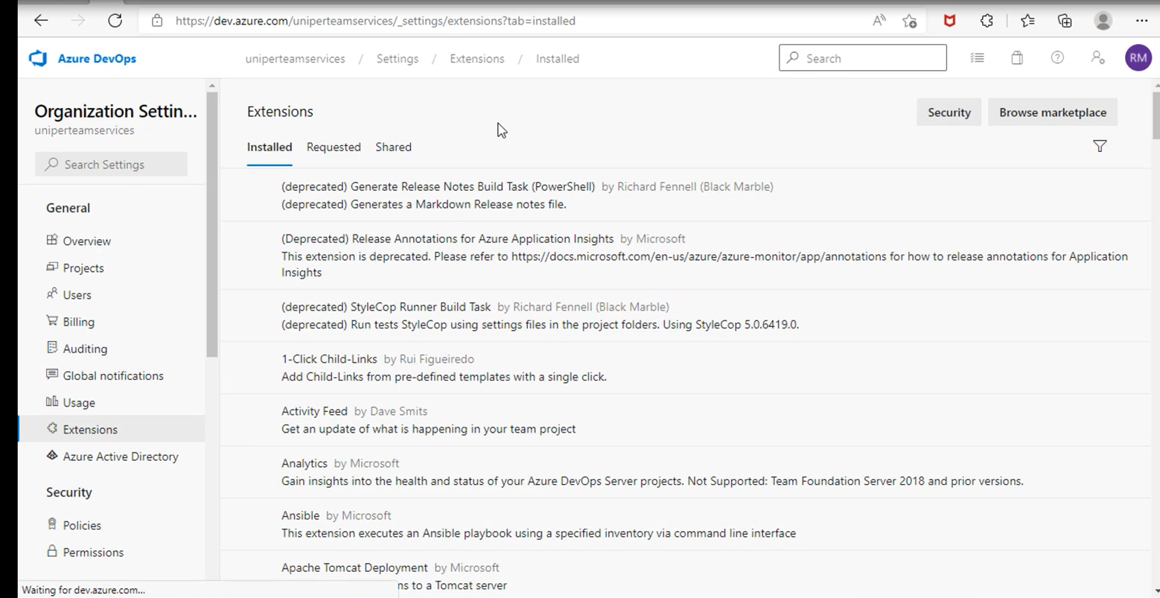

**13. Auditing:**

* All the activates we can observe from auditing. If we face any issue, we can check the audit logs.

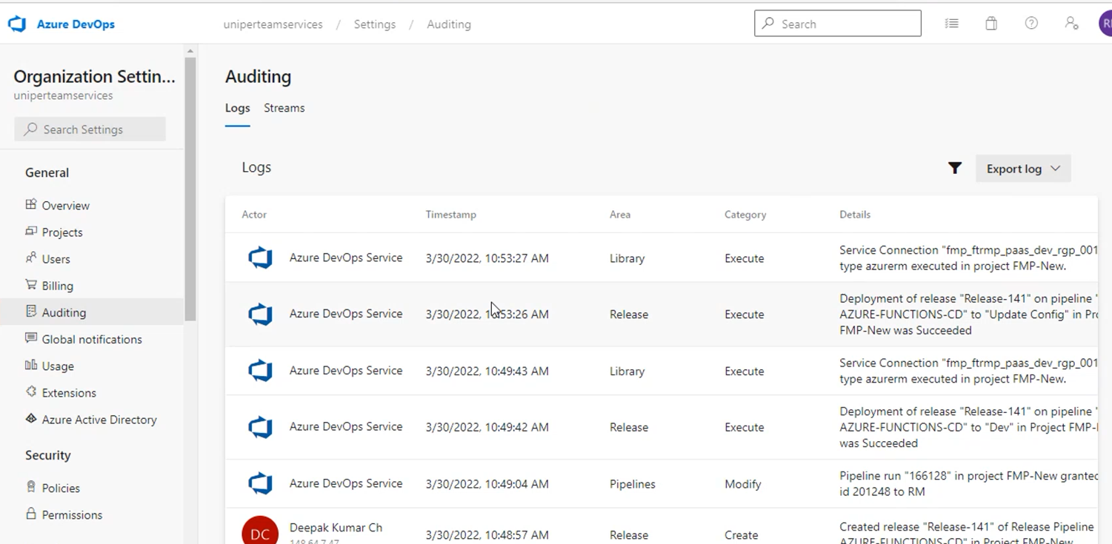

**14. Permissions:**

* From screen shot all are default roles. Except External Project Collection Administrator (PCA).

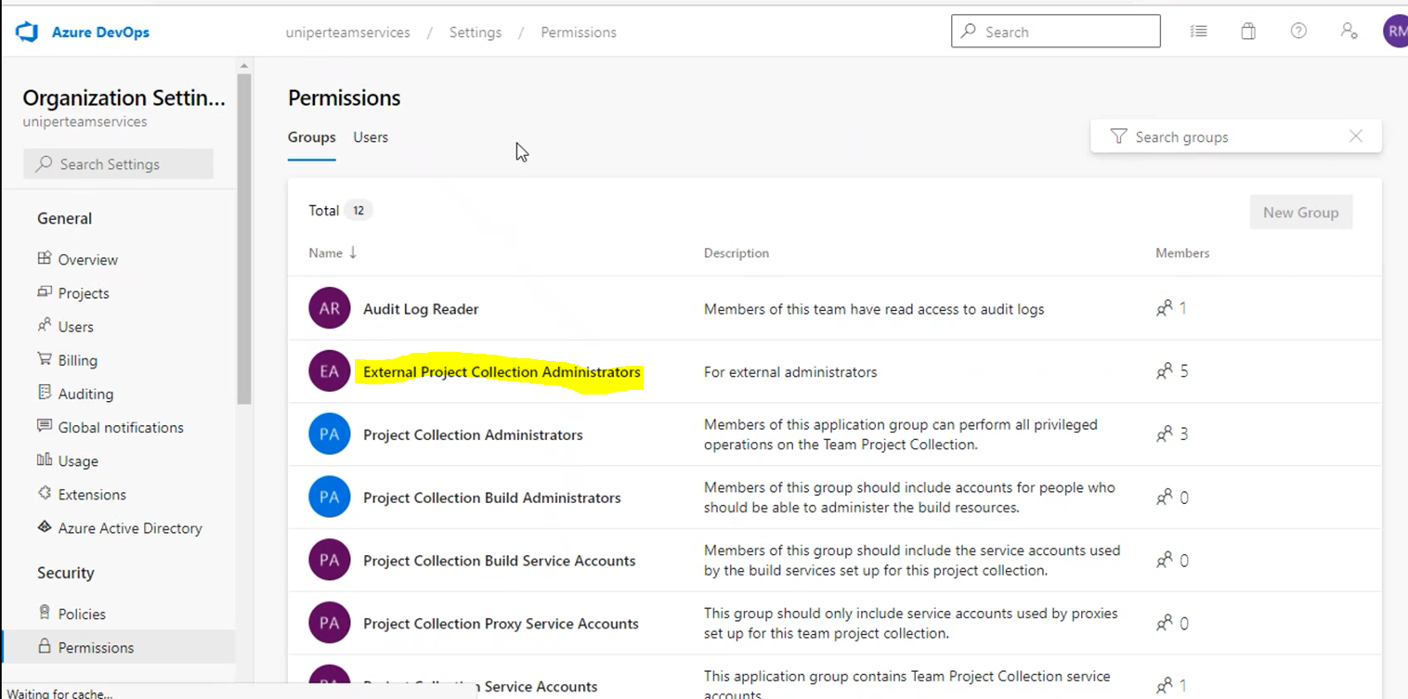

* Project collection Administrators are the global admins, they can do everything at entire organization level and Project level.
* **External Project Collection Administrator** role is replica of Project collection Administrators. For this role we don’t have permission to add new people into organization now.

**15. Create Project:**

* Users will raise snow ticket to create new project. While submitting the request itself they will select one project administrator.
* We will take the request and we will create project and we will add one user as Project Administrator. Further activities will take care by Project Admin. Like Adding new users into project.
* In case of project admin not available, we can help them on this.
* Here we have the link for reference for project creation.

<https://wiki.intranet.uniper.energy/sales/display/CF/DevOps+-+Create+new+Azure+DevOps+project>

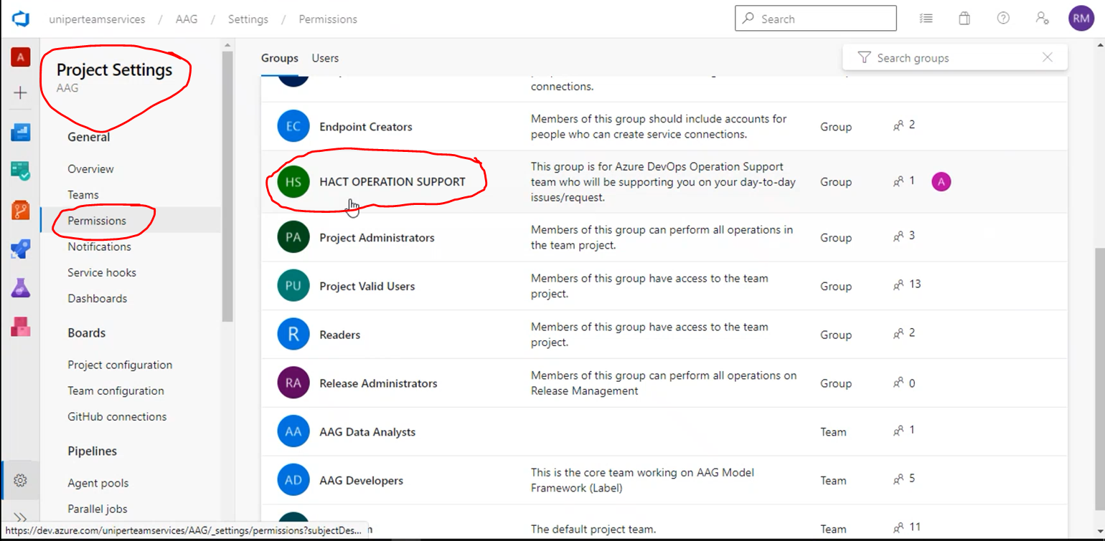

* Once we create the project, we will create new group with **HACT OPERATION SUPPORT**, so that people part of this group (DevOps) will access the Project and guide them if they get any issues.
* Once **HACT OPERATION SUPPORT** group created, we need to add this group to Project administrator group. This means **HACT OPERATION SUPPORT** members are project administrator.
* We need to add group not individual id.
* If we don’t add this group to project, we can’t see this project from our end.

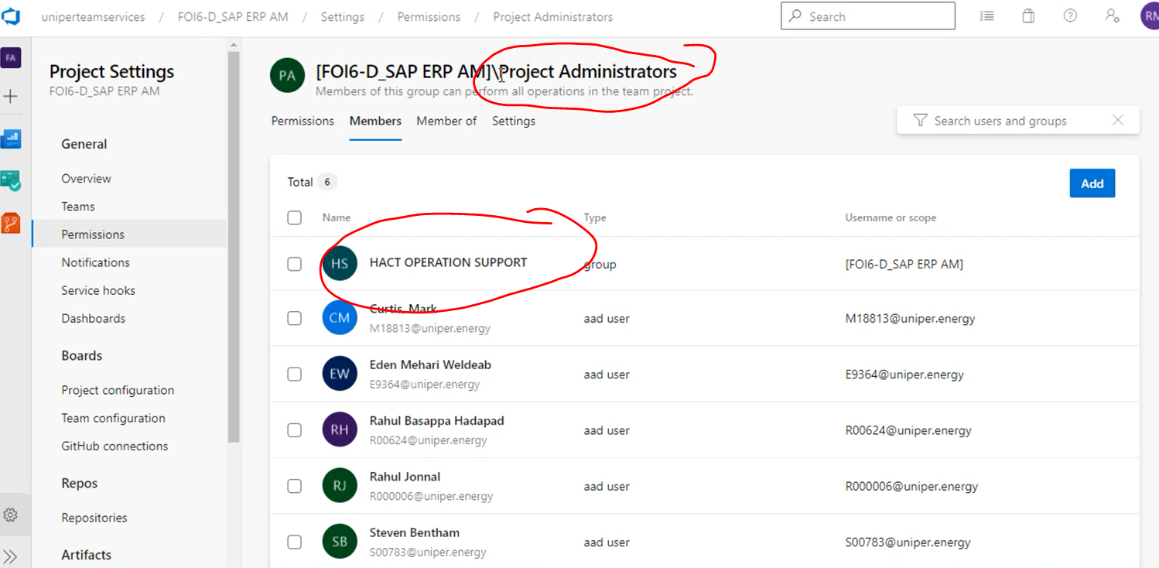

**16. Process:**

* we will mostly follow scrum.

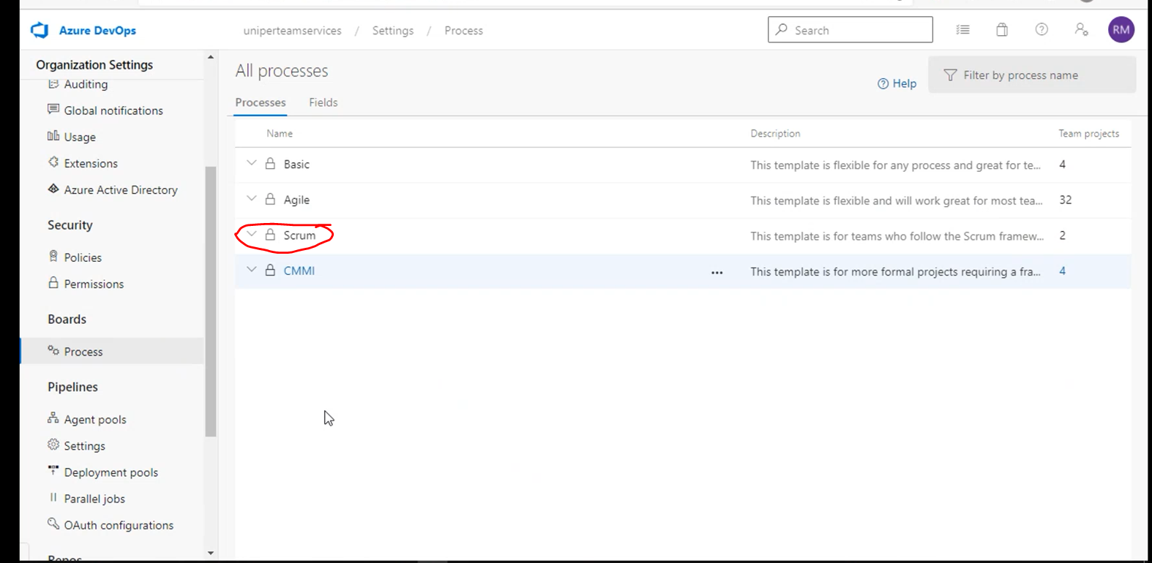

* By default, we follow the below process template.

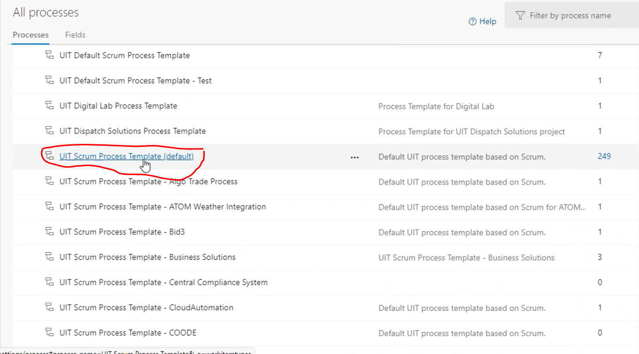

* User may ask for the custom process template, we can ask them raise request for that. We will create assign them to their project or their project admin will take care.

**17. Agent Pools:**

* Most of the agent pools are self-hosted agent pools.That will be monitored by application team only.

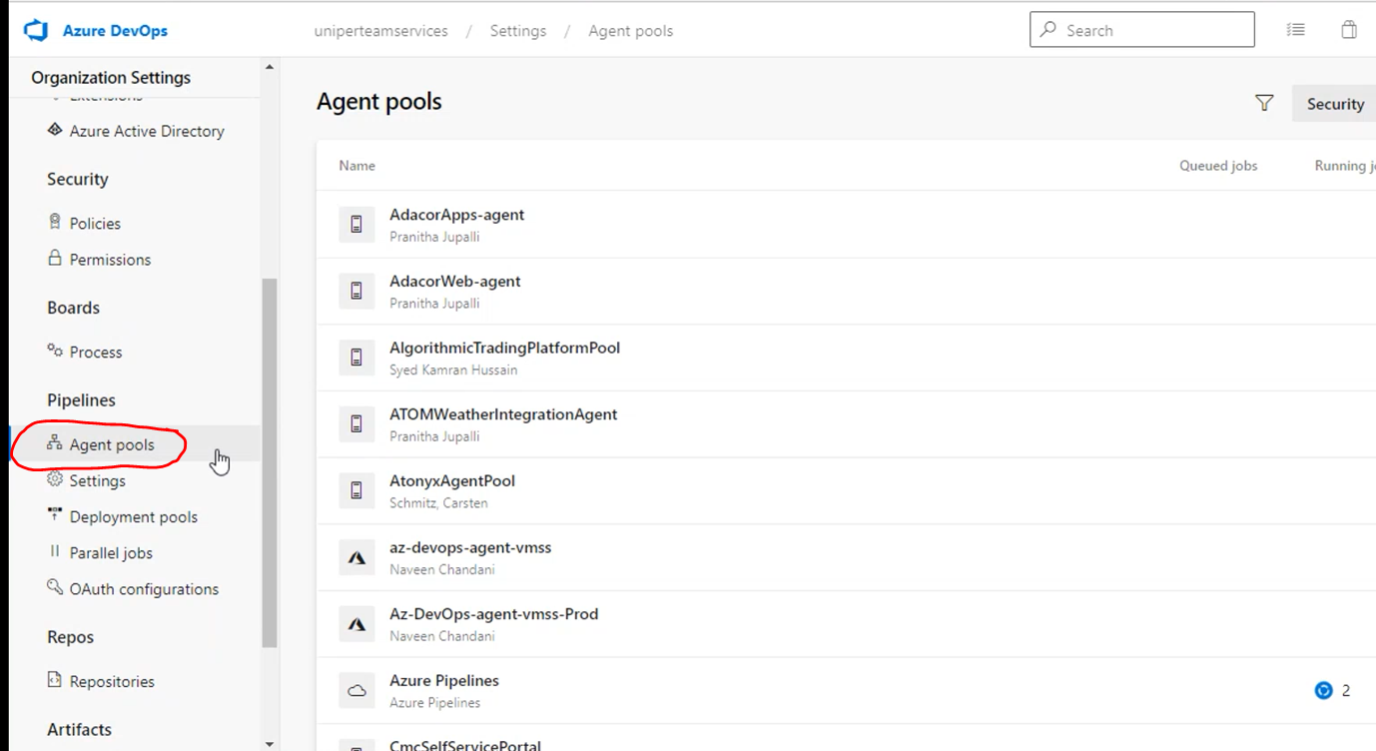

**18. Process of raising selfhosted agent request:**

* If any of the team wants new agent pool, they will raise a request to us. Once request raised, we will reply to them that raise a- request for get a vm from infra team and provide access to us.
* Once they provide access to us, we will install that agent and we will add that pool into project.
* Once agent was added, we will ask them to check if everything looks good. We will ask them to remove our access for vm. Because self-hosted agents managed by application team not from DevOps.
* There is a one selfhosted agent running inside pods, which we will provide as service, if any of the team wants. We are managing this agent pool.

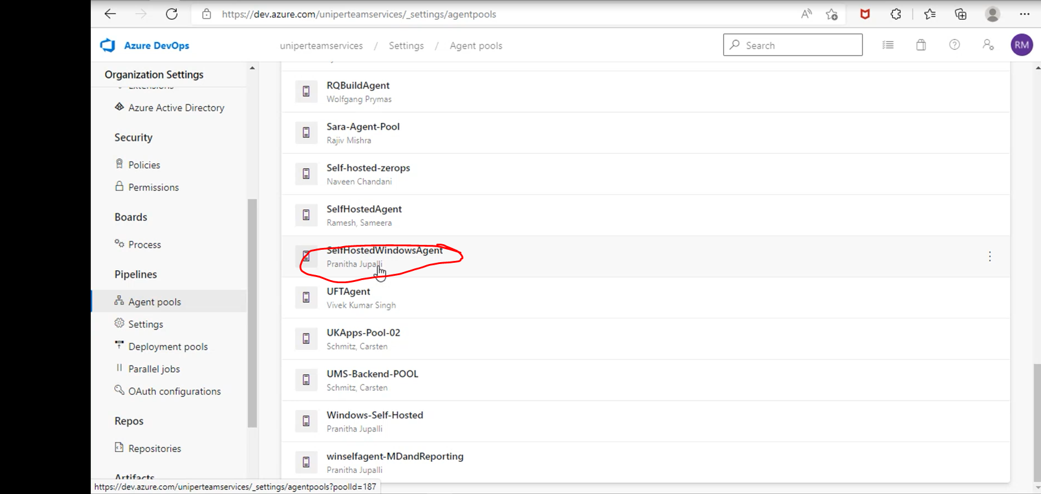

* We will manage only one project CMC Sprint Planning out of 500 project.This to mange our work in sprints.
* Entire uniper is use this project only for sprint planning.

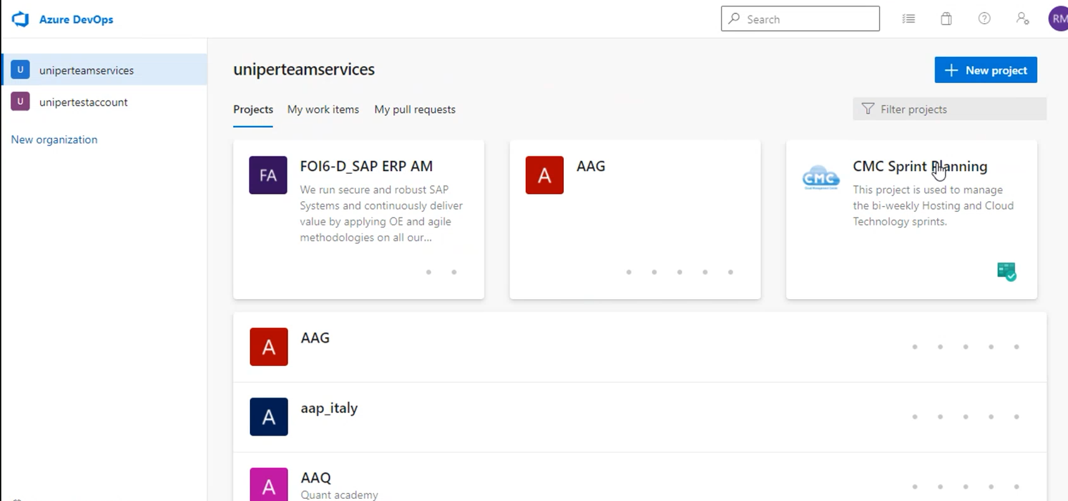

**19. Service connections:**

* We will get service connection request for 3 things.
* Service connection for Resource Group (Automated)
* Service connection for Registry (Manual)
* Unipertestregistry (R&D and POC) (Manual)
* Unipercontainerregistry (Production) recommended this for users.
* Service connection for Cluster namespace.
* Service connection for Resource Group will be done by automatically.
* Users are not responsible to create their own registries.
* Once user request for service connection for this registry, we reach out to directory service team to provide service principle. Once service principle created, we will get details from directory service team.
* we will use this service principle for to create service connection.
* Service connection for cluster Namespace done by manually not require service principle.
* Service connection for sonar cloud—app team responsibility, we will guide them.

**20. Automation scripts:**

* DevOps Automation prospective we have below Automation scripts which are being used.

**1.License Management** (stake holder, basic license is being granted automatically).

**2. Audit log backup**

**3. License reminder**

**4. Service connection management - CMC portal** --currently using.

**5. Service connection management** (manual intervention not required) - integration with SNOW -- for now implementation InProgress -->once it is ready in SNOW CMC portal (manual intervention) might be removed.

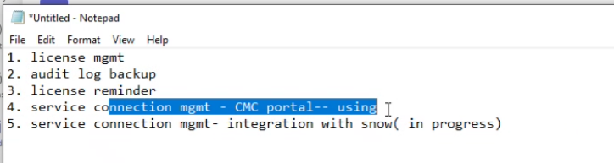

* In service connection management, CMC portal need some manual intervention required. When users are submitting requests through the SNOW catalogue, we must take the values from SNOW catalogue manually and fill into CMC portal then must submit the request.
* Service connection management (manual intervention not required) - integration with SNOW -it is InProgress from Client side, once it is done, we will get KT from client. Here SNOW request will automatically pick up and execute script, then user requests will be served without any issue.
* For now, we have separate Central Automation team and they do automation for all the areas. if any (Azure Devops) team having any kind of automation tasks they will give the requirement, then automation team will automate it and give back to them (or Azure Devops team).
* So, development of the automation will be part of automation team activity. But once automation is done, automation team will hand over to the respective required team.
* Azure Devops and Azure AKS teams are working together to deploy apps into AKS cluster environments. Once Azure devops pipeline runs AKS cluster environment is being deployed and taking care of development and modernization.
* Cluster operation is with deferent team, previously year 2021 we had a dedicated cluster environment like each application will have a separate cluster, due to cost and billing uniper came up with shared cluster. and now each environment has separate clusters and apps are segregated with namespace and being deployed. Maximum we have 4 to 5 clusters.
* We have these environments, preprod, prod, cmcpoc, preprod hisec, and prod hisec.
* When we migrated entire application, it must be stable, then Operation (BIU) tasks like creating namespace, on creating users’ day to day issues and BIU kind of cluster work given to the our internal working teams (Linux infra team).
* Linux infra team will take care of operation part and we (Azure Devops) do development tasks like modernization, enhance new features.etc
* Azure Kubernetes operation is with Linux Infra team and Development part is our (Devops) team responsibility.

**21. Sonar Cloud:**

* Sonar cloud service connection is app team responsibility, but in case if they do not know how to create Service connection, we must guide them.
* Below are the majorly used in Sonar Cloud

1.Create and delete project

2.Onboarding user/group

3.Getting permissions to projects/groups

* We have organization called **Uniper,** all the projects in the Uniper to scan their applications through the Pipeline is being created under Uniper only.
* To see the all the projects that are being scanning in SonarCloud, go to Administration ->Project management.

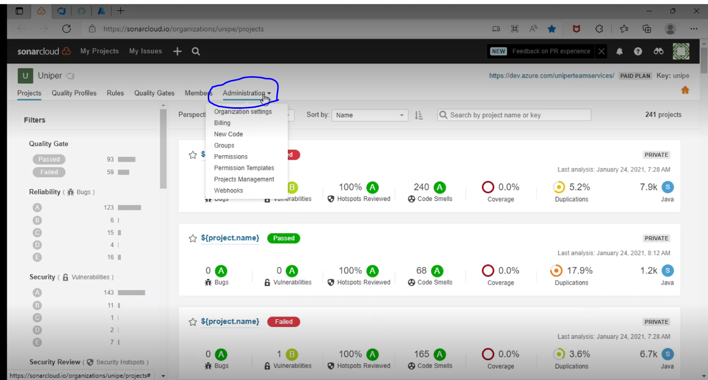

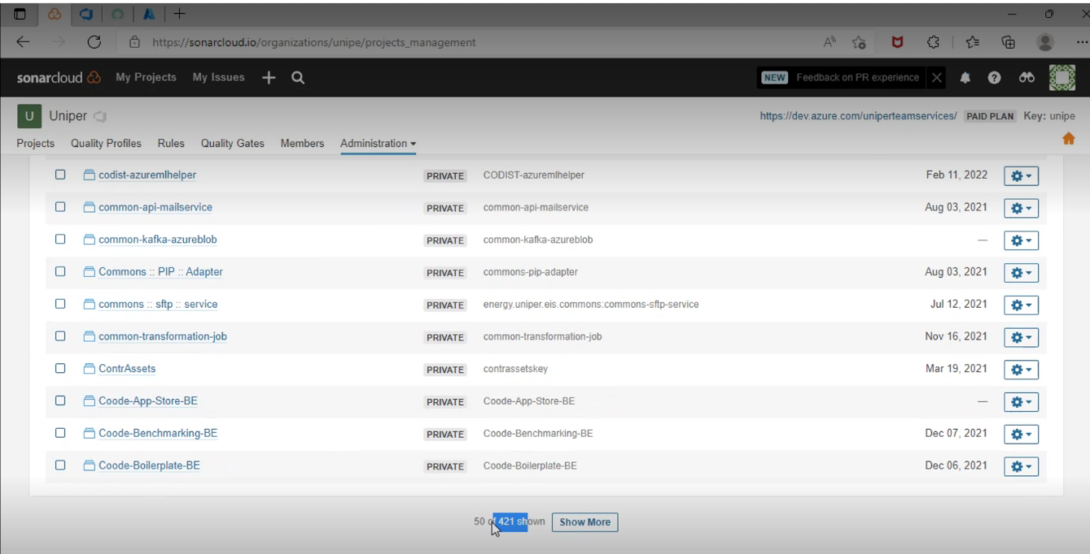

* Some of the project may not scan their project through Sonar Cloud.
* So far, we don’t have any SNOW catalogue to granting permissions to project/group. generally, granting permission kind of tasks are responsible of Project administrator like way we Azure DevOps.

**22. Create and delete project in SonarCloud:**

* To create Project in Sonar Cloud, click on **Analyze new project** and **create Project manually**

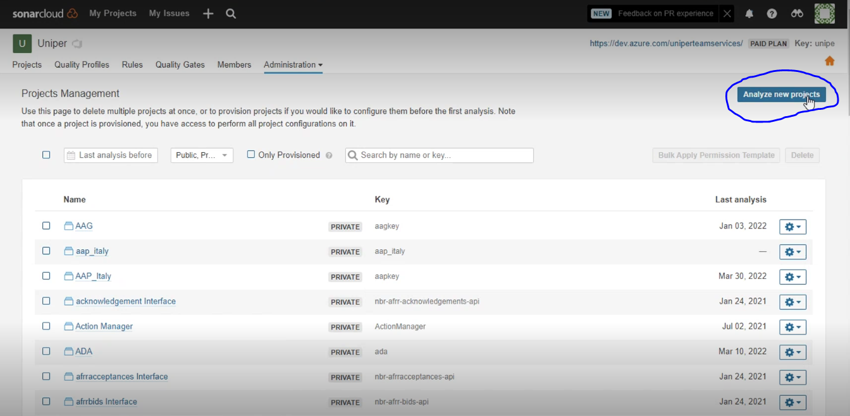

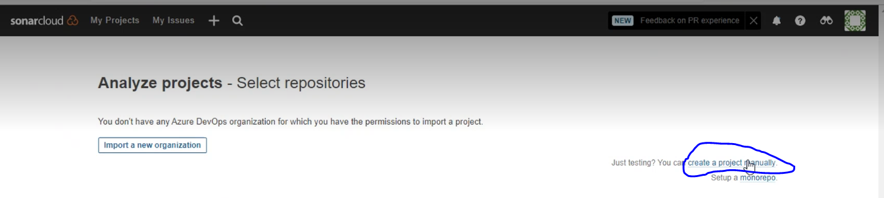

* Give the parameters according to requirement and mostly it must be Private

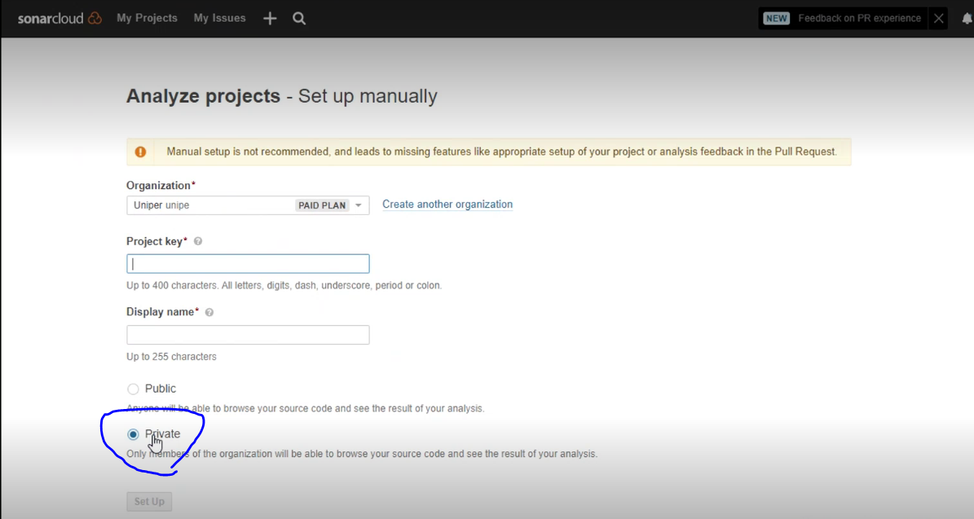

* Once project is created, reply to user. And provide Project name, project Key (similar to what project is (should not be capital and special character in project key)).
* This project name and project key must be required while Pipeline configurations when they try to integrate.

**23. Onboard user/group in SonarCloud:**

* Once we provide the project name and project key, user will reach us to provide access. Then go to member ->add a member ->search with KID or name

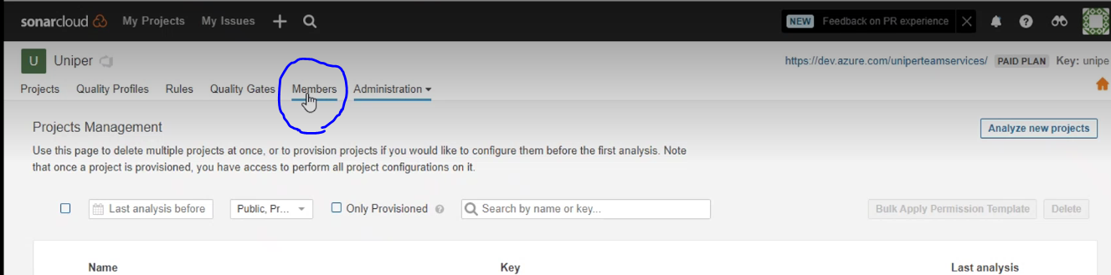

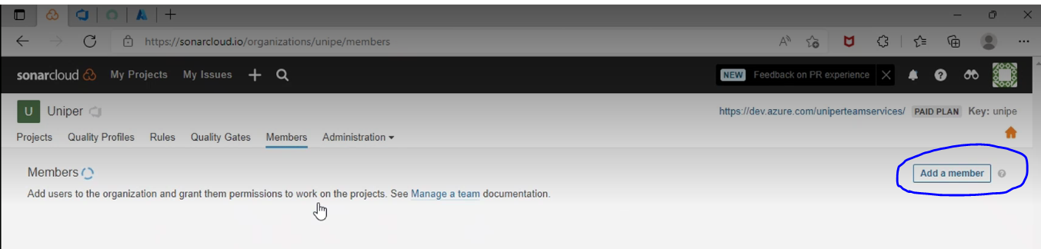

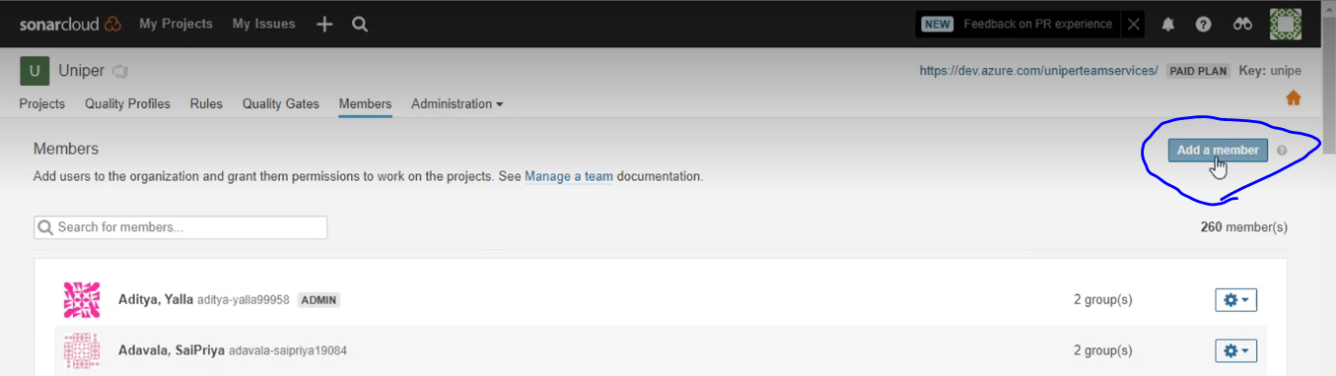

* In order to have login access to Sonar Cloud, user must login to sonar cloud with their KID, Once login to sonar cloud automatically random entry will be created with KID.

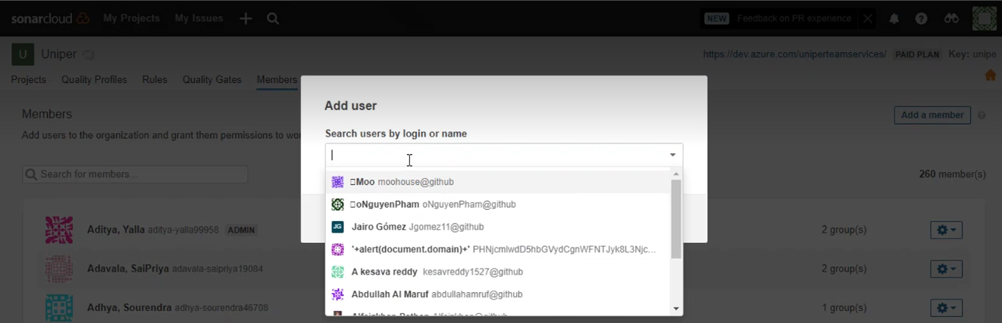

* Our responsibility is adding members to the Organization, and Project administrator responsibility is adding members to the Projects, similarly like Azure DevOps.
* Sometime if Project administrator is not available, we need to be given permissions to project, based on user’s requirement.

**24. Adding users to the Groups in SonarCloud:**

* go to Administration ->Groups

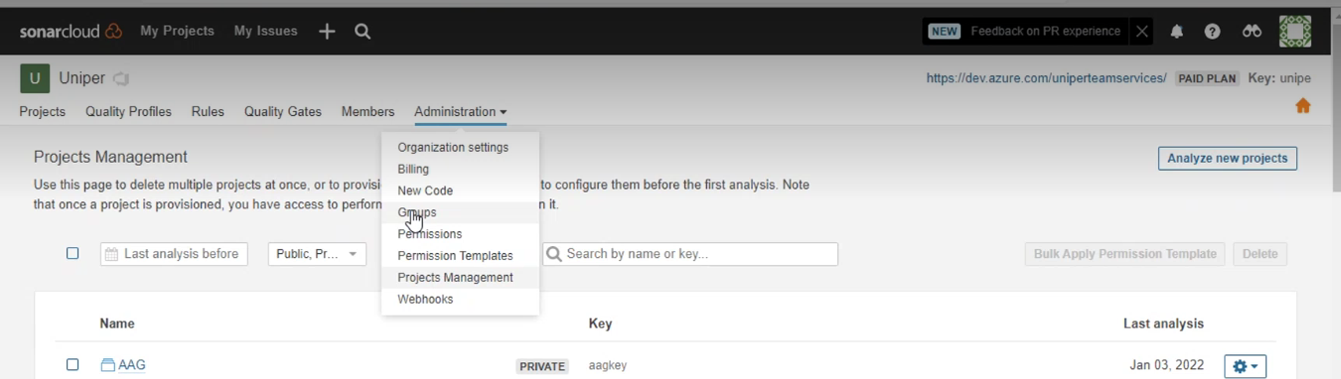

* Select the Group and click on symbol as show in screenshot

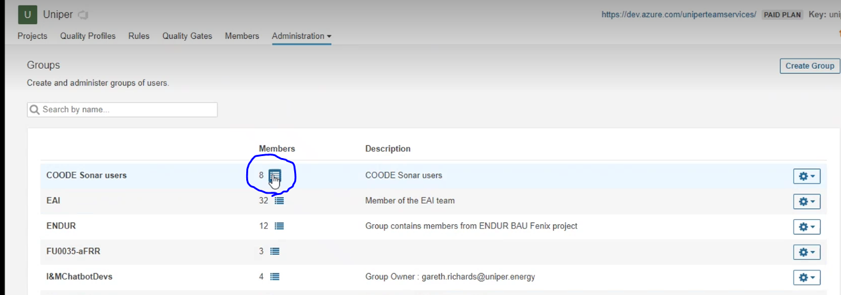

* Search with KID or name, if not be a part of to that project check the check box->click on done

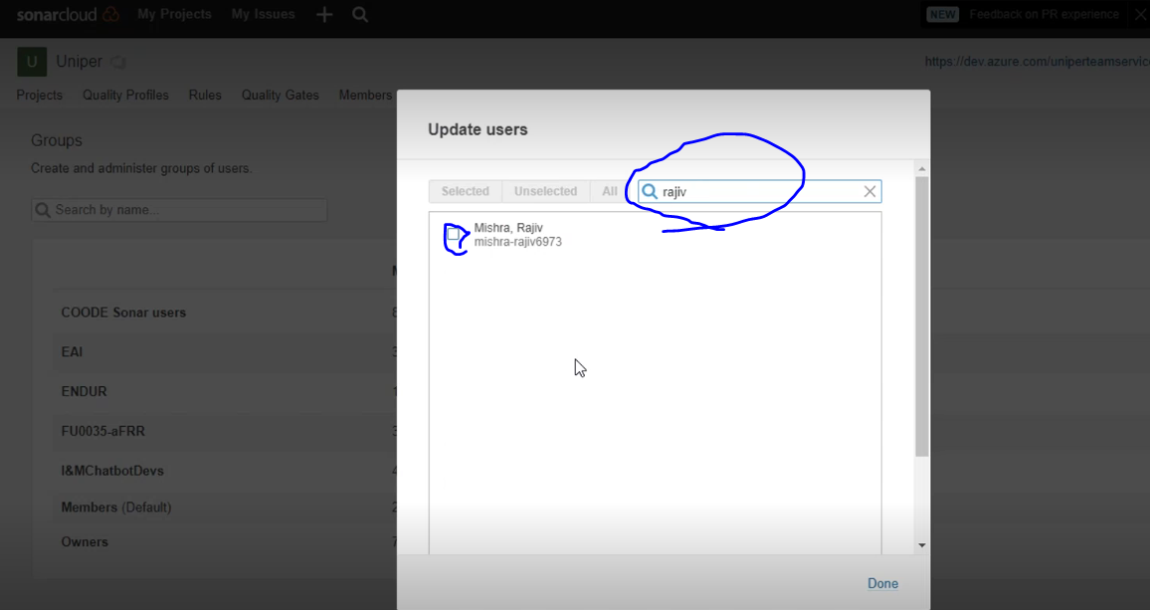

**25. Service Connection to Sonar Cloud:**

* Go to right side top Account->My Account

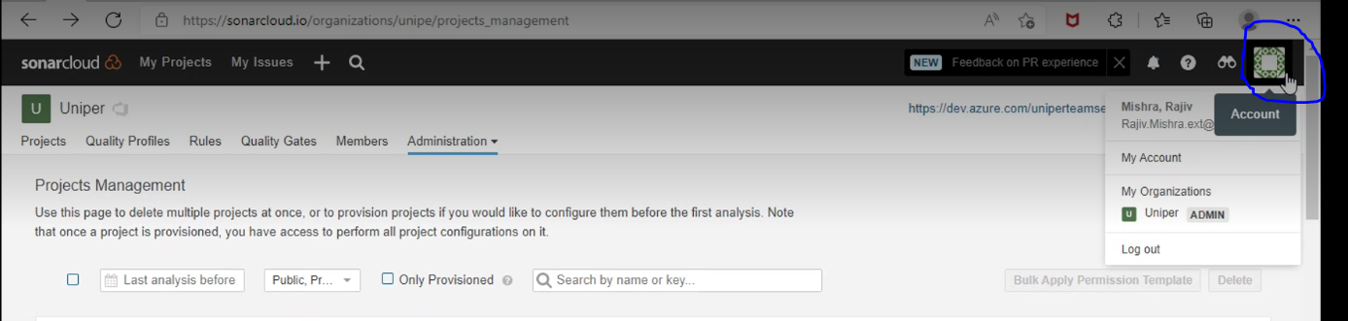

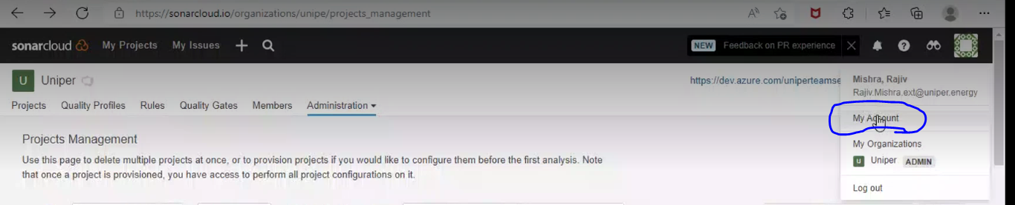

* Under My Account, there is Security tab-> click on Security

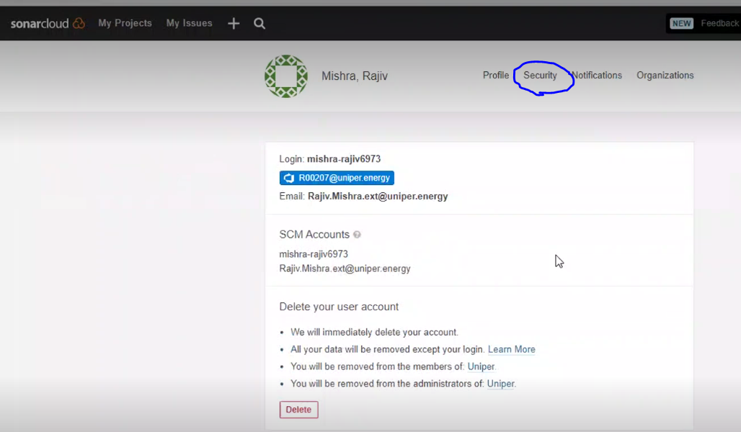

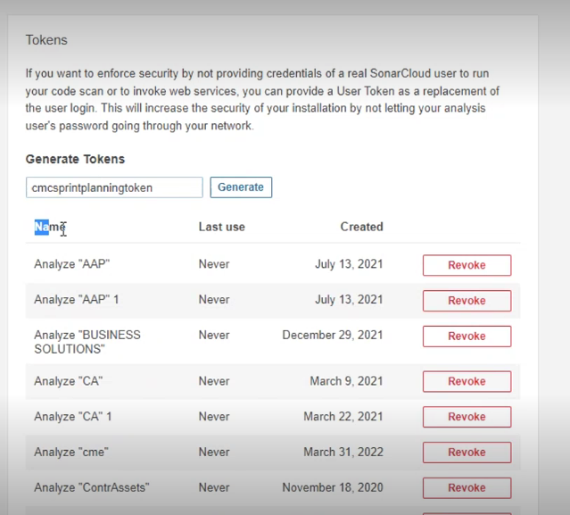

* To generate token, give any name randomly with meaning full and click on generate, then random key will be generated.
* Copy the Key, then go to project (which you want to create Service connection)->go to service connection ->New service connection->search for Sonar Cloud->click on Next… it will ask you Sonar connection Token, service connection name. there you must give same Token which we created.

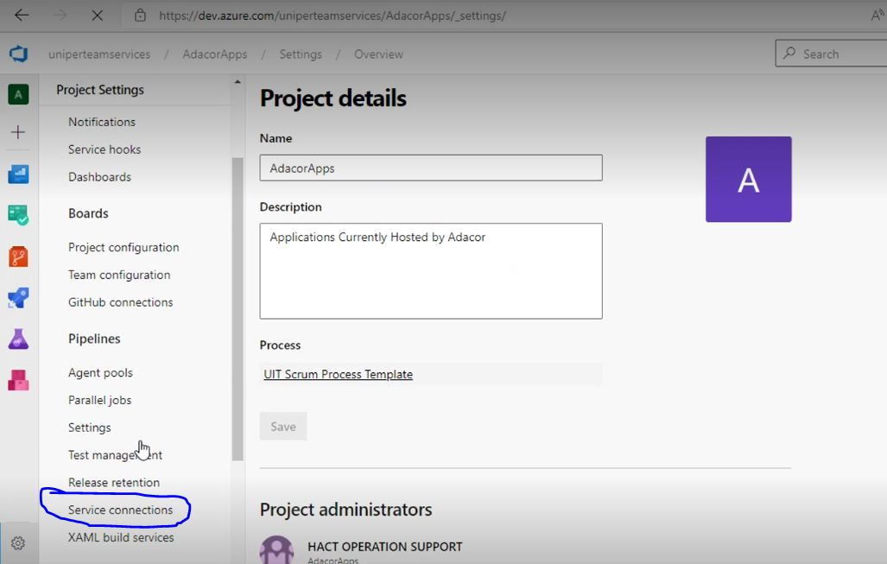

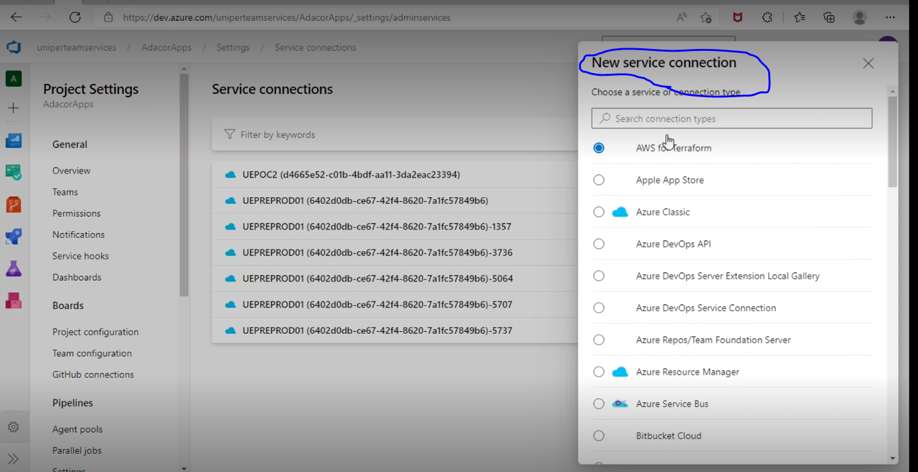

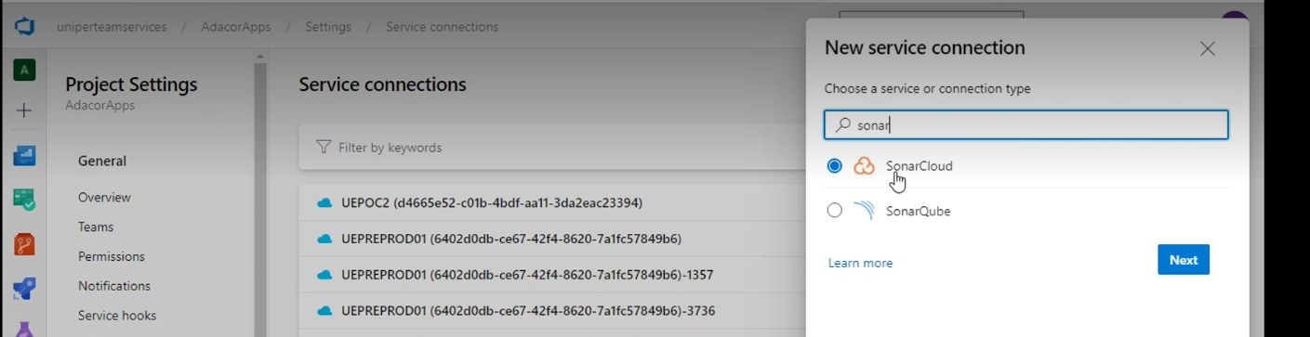

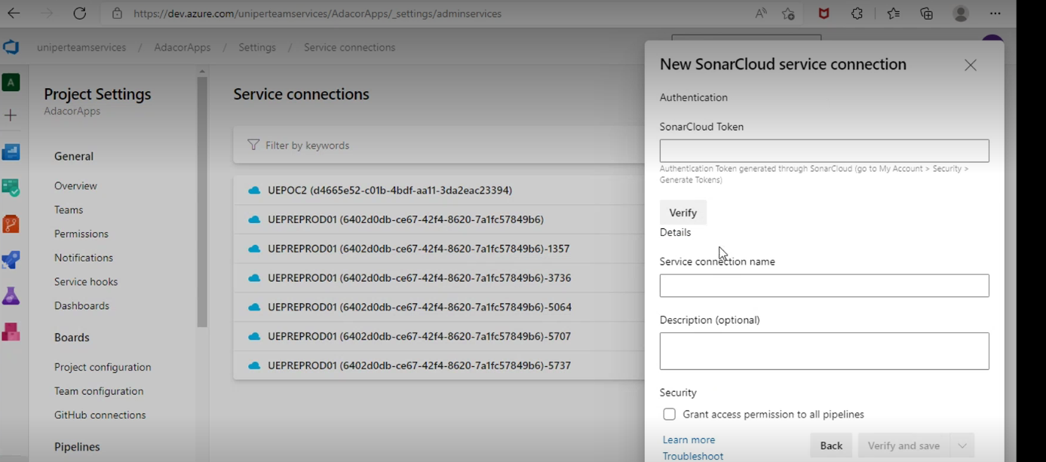

* Use this create Service connection to do static analysis in Sonar Cloud.

**NOTE**: this must be done by App team.

**26. Azure DevOps and Sonar Cloud Integration:**

* Azure DevOps have deeper integration with various enterprise Eco-system. One such integration is with SonarCloud.<https://wiki.intranet.uniper.energy/sales/display/CF/Azure+DevOps+and+Sonar+Cloud+Integration>

**27. CMC Managed Containers:**

* In future, we may get to create cluster we can use “AKS Cluster creation using Terraform” pipeline. No need to create manually.
* Users need to pass input parameter to create cluster, then pipeline will automatically create cluster.

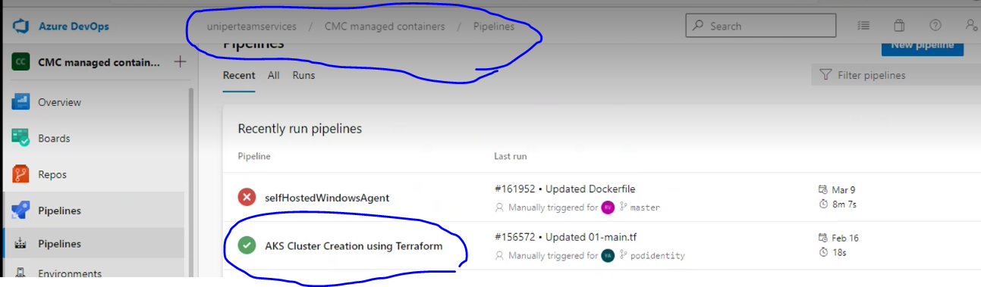

* There is one more automation done for “Cluster Namespace”.

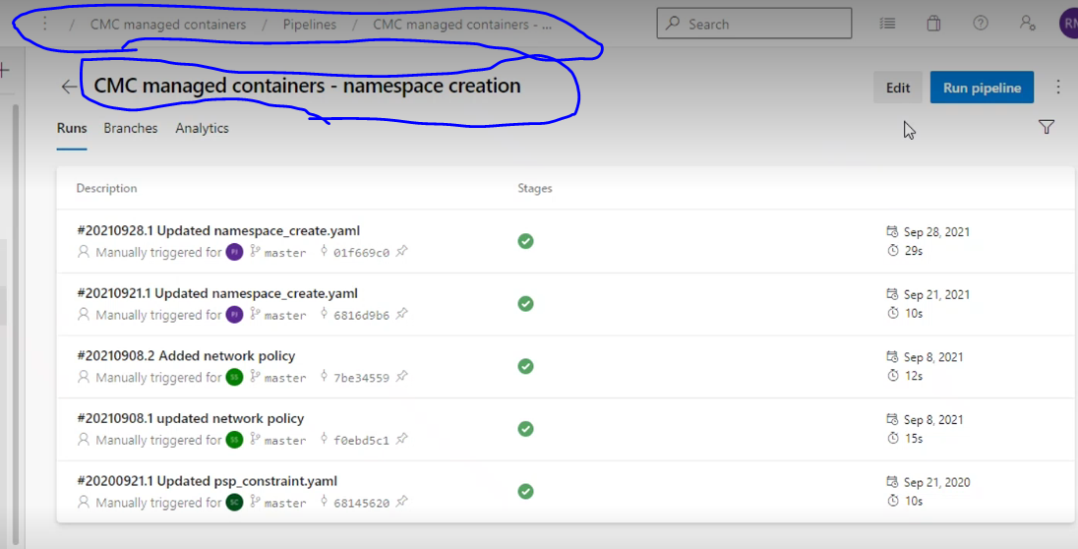

* User will provide their input parameters and then run the Pipeline.

**28. Logic App:**

* We can do the automation for below tasks using logicapp.

1.License reminder

2.Audit log backup

**28.1 License reminder**

* We have around 2100 users.
* We have configured logic app, for sending periodic reminder for License expiration for 90 days every user, and who has not accessed the from last 30 days.
* If user did not require those licenses, we have to cleanup those licenses

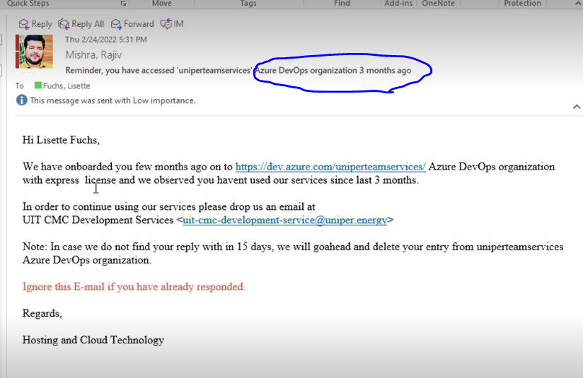

* 1. **Audit log backup**
* All the events are being captured in Audit log

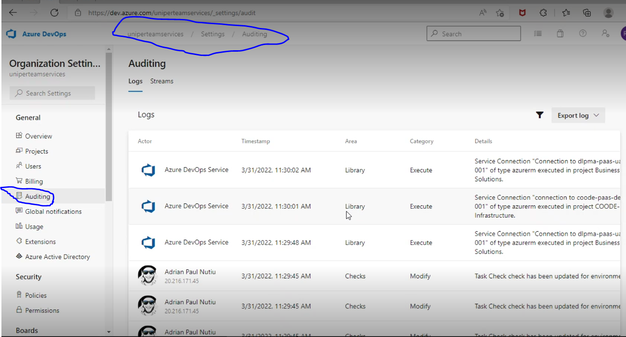

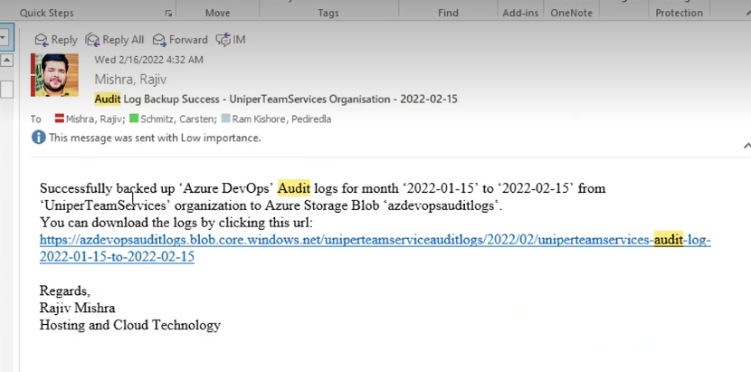

**29. Logic app user task:**

* Select User-task-01

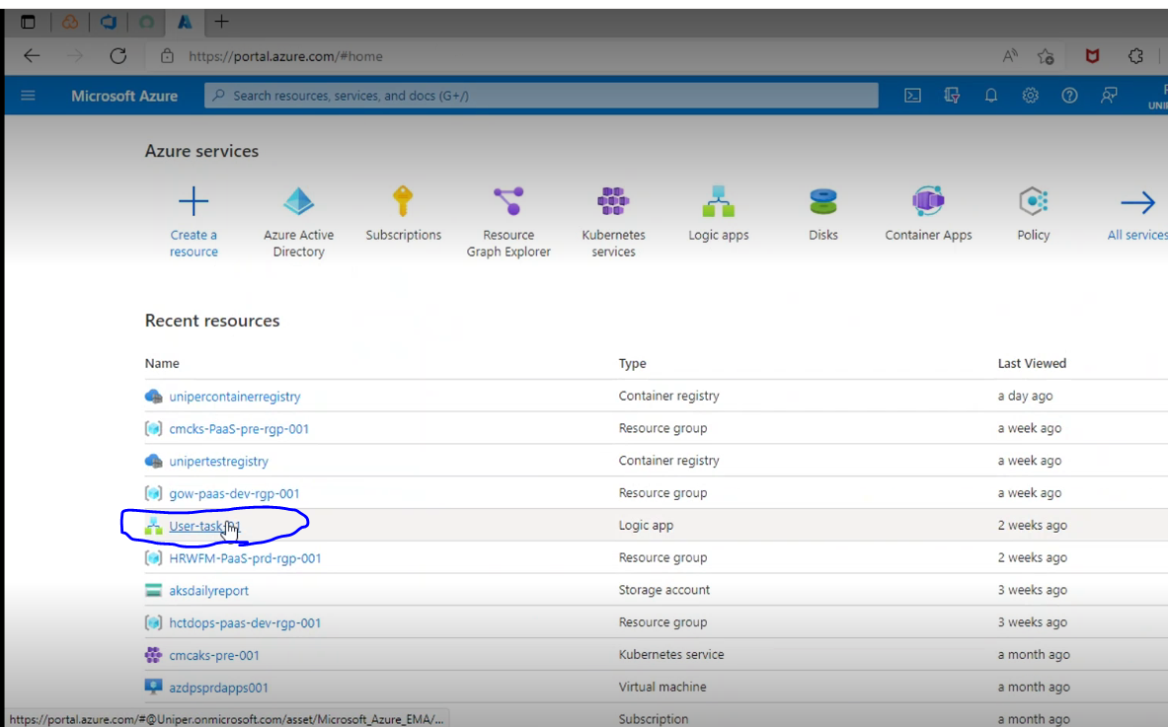

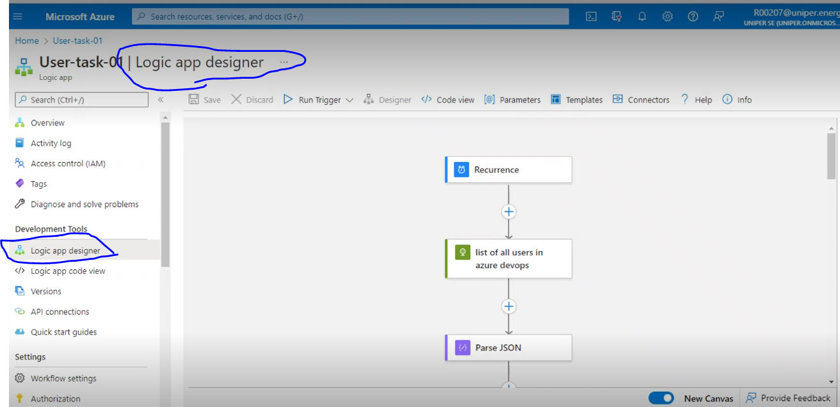

* click on each tab and check the API and parameters are being selected through Logic App

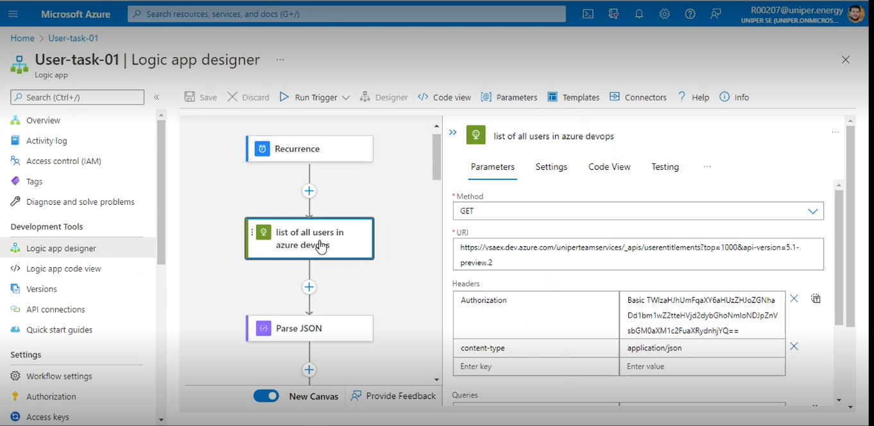

**30. Repositories:**

* We have majorly 3 repositories

1. **Github**
2. **Azure Devops demogenerator**
3. **Wiki documents**
   1. **Github:**

* github is version control system, it will check in our code, maintain pull requests, setup various kind of pipelines.
* there are different kind of accounts and licenses we have at the Github level. The license which we are using called github enterprise account.
* in github enterprise account we will have many organizations, organizations are nothing but business units, and for now in Uniper Carsten and rajiv are the owner of the Uniper github account.
* we have 2 different organizations. 1. Uniper |Digital Trading, 2. Uniper IT

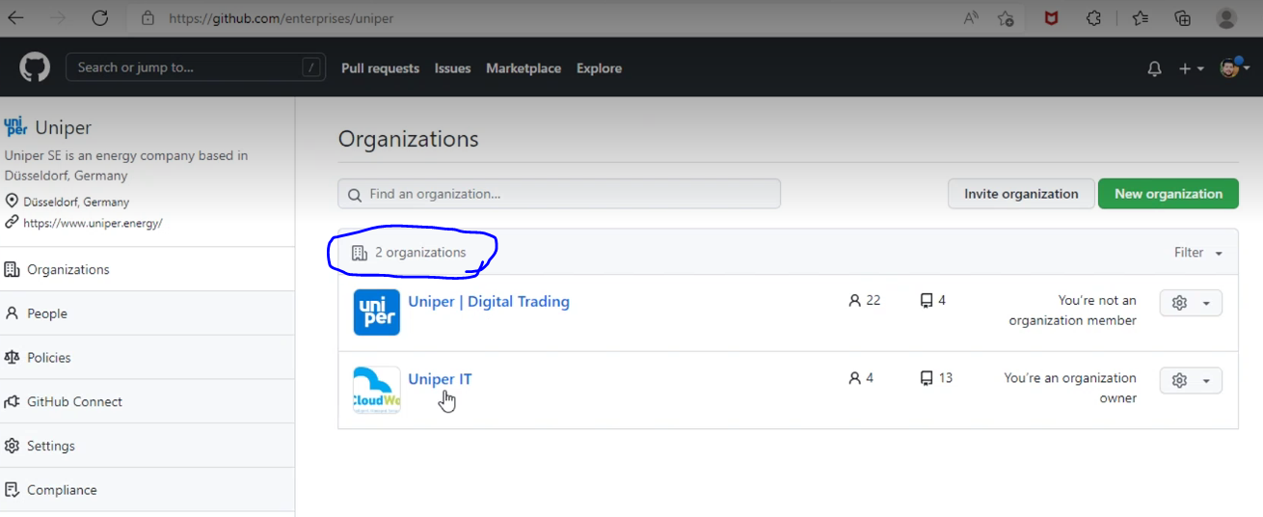

* in one business unit, there are many applications and each application categorize under specific repository and projects. there are being enabled many policies and settings In github account.

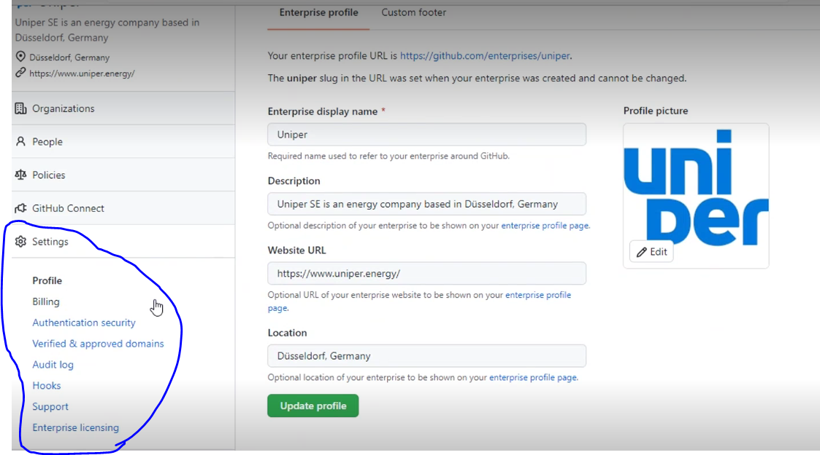

* similarly, Uniper enabled certain policies. Policy is nothing but kind of rules which will be apply to all the organizations settings. And all organization having their ow policies.

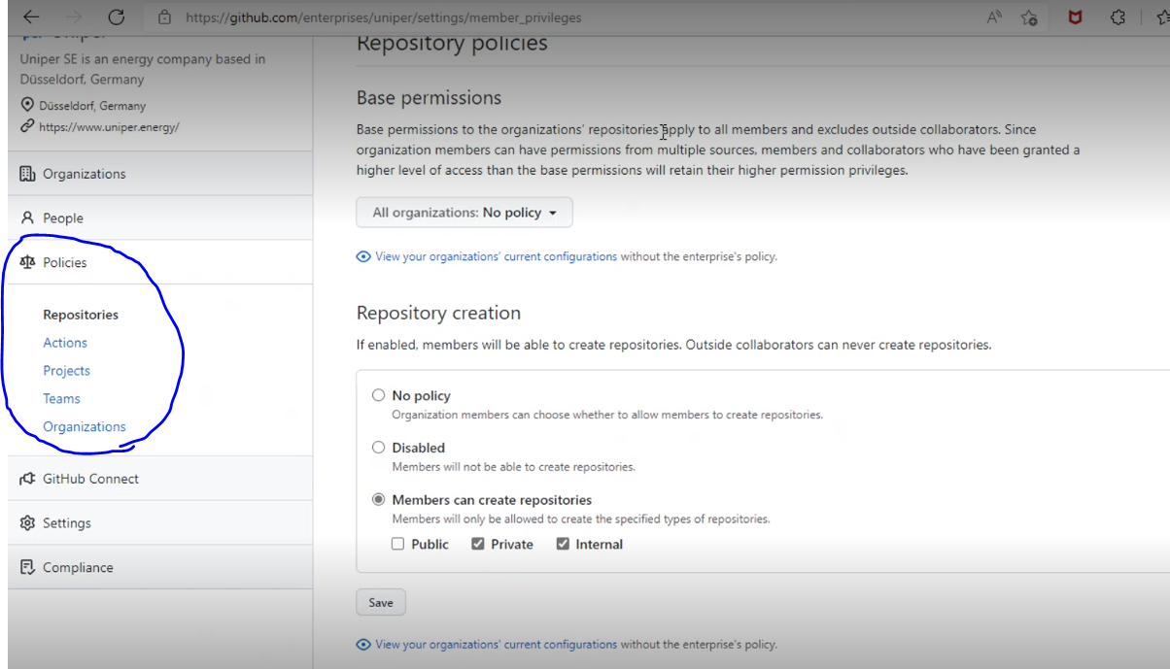

* for now, HAcT at the enterprise level, and we may not involve in organization level. But here based on the user request we will create organization once setup the organization we should set admin to organization. Then admin will be responsible for organization administration, like repository, adding members to the team, any kind of policies and setting up the org level.
* in enterprise level Devops team will manage.
* We must create the service connection for the github aswell.
* Rajiv created 4 catalogue and given to carsten. Eventually they will plan to rollout for the users from SNOW. Currently martine is working on these catalogues to put into face.

Those trail catalogues are

1. Onboard new users
2. Create new organizations
3. Selfhosted runner access
4. GitHub- service connection

**30.2 Wiki Documents:**

* we already have access to Uniper wiki links. There we can find all the documents.

[Dashboard - Uniper Wiki](https://wiki.intranet.uniper.energy/sales/#all-updates)

**30.3 Azure Devops Demo generator:**

* it is a platform, which provides not only to create the projects which is being offered by Azure demo generator, but al so we can create our own custom template, then we can use those templates to create the projects.
* by using the Azure Devops Demo generator, we can create a project by using template.

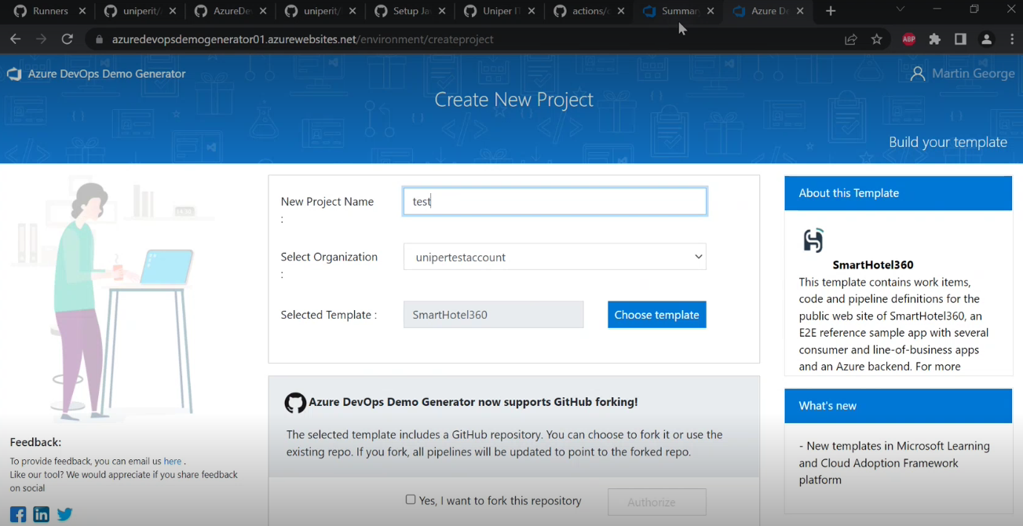

* Azure Devops demo generator is provided by Microsoft, and Microsoft will provide code for Azure Devops demo generator.
* By using the code, we can deploy our own cluster environment on Kubernetes infrastructure. Then use that cluster as application.
* Basically, while creating project, we will come across Boards, Pipelines, testplans, repo’s, artifacts etc.

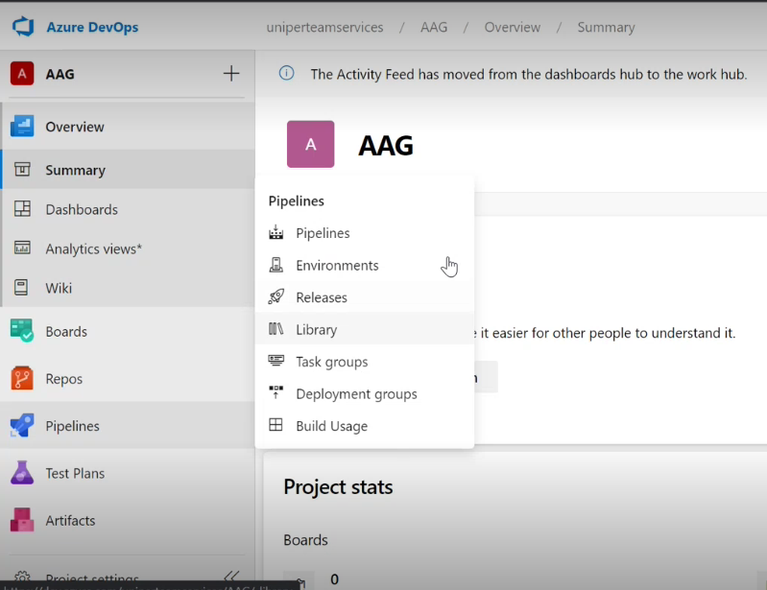

**31. Storage table:**

* For this uniper team has setup a PowerBI dashboard, there we can find the Devops projects, how many users, how many images in registry, how many cluster application... and so on...
* Basically, PowerBI does not have REST APIs to pull data, so we are maintaining storage tables in between. The storage data table will pull the data from Azure, Azure registry, cluster and AzureDevOps and placing into 3 different tables. From there PowerBI is pulling the data.

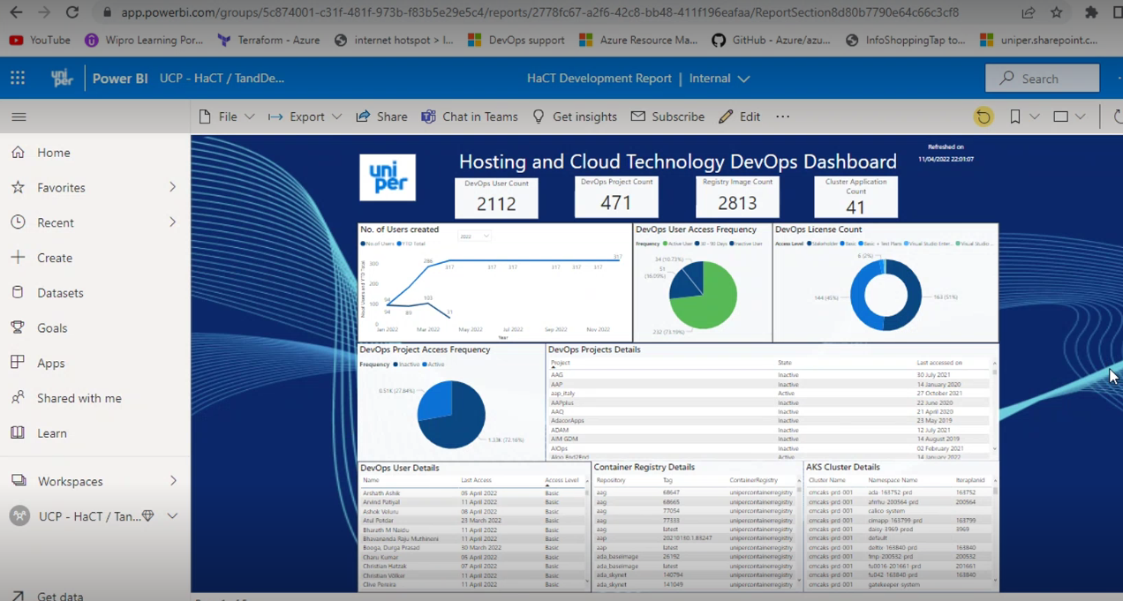

* automation team will pull all those data from all the teams and streems and place those data on every Wednesday (8pm CET) into storage table (ARC, ADOProjects, AKSNamespace). and PowerBI tool will pull the data (at 9pm CET) from storage table and refreshing the report.

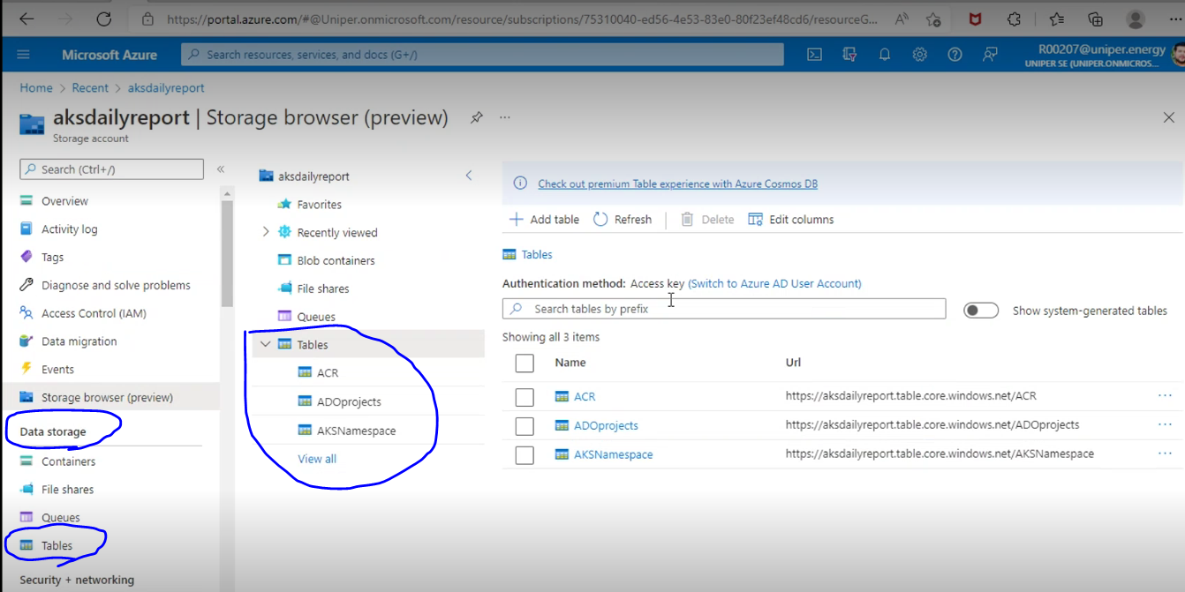

**32. ACR Task:**

* this is come up when the when the UniperContainerRegistory repositories are growing more in mean time and not able to filter out and find those new repositories.
* So, we have setup one ACR task. Through this task we setup rules which will clean the ACR repository if the count is more than threshold.

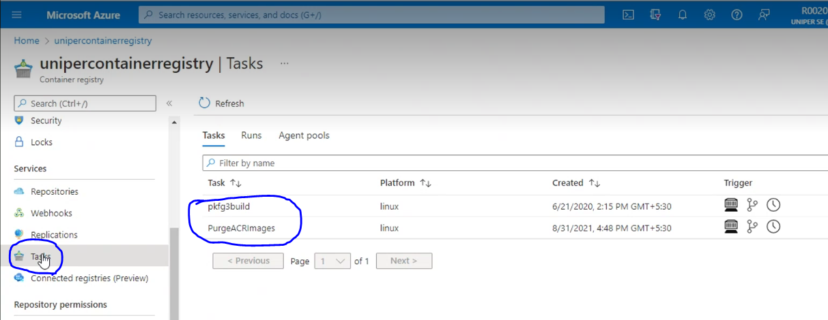

* We have kept threshold as 5 and 7, so in the UniperContainerRegistory if the image count is more than 5, on every Monday (around 8 am CET) morning the older image will be deleted. Per suppose if there are 7 images, then last 2 old images will be deleted and 5 new images will be in storage.

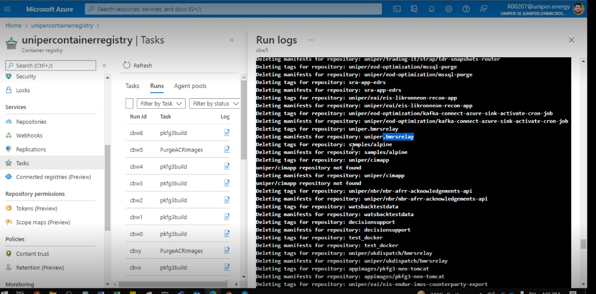

* If suppose, some users may contact us to not deleted their images, we can mark those images from the deletion list. For that we have a script which we can run manually, or we can setup through pipeline as well.

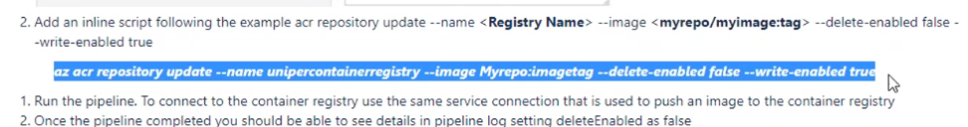

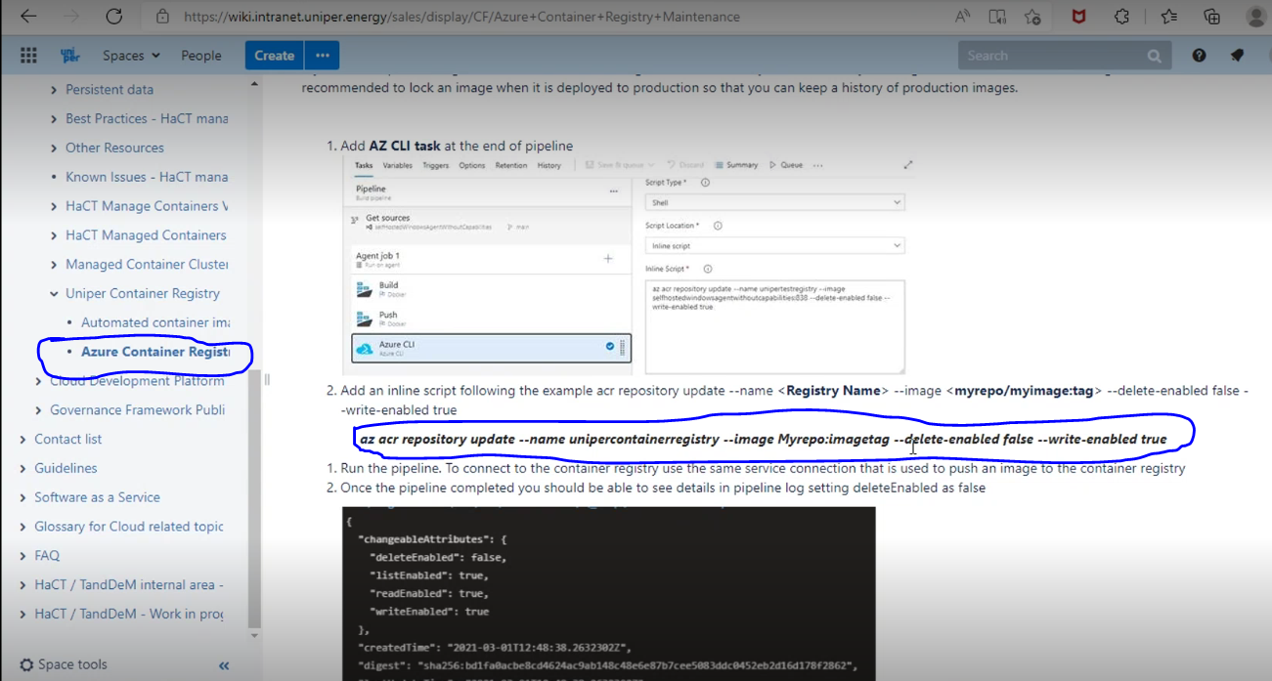

* Basically, we have Automation as on below tasks

-ACR Task

-Storage table

-Agent running as a container

-Logic App

-Basic + Test plan license management

-Service connection for Resource Groups – InProgress for now

**33. GitHub runner:**

* Github actions are help us to automate CICD Pipelines, they written in workflow files (.yml files)
* Workflow files written for every github repository.

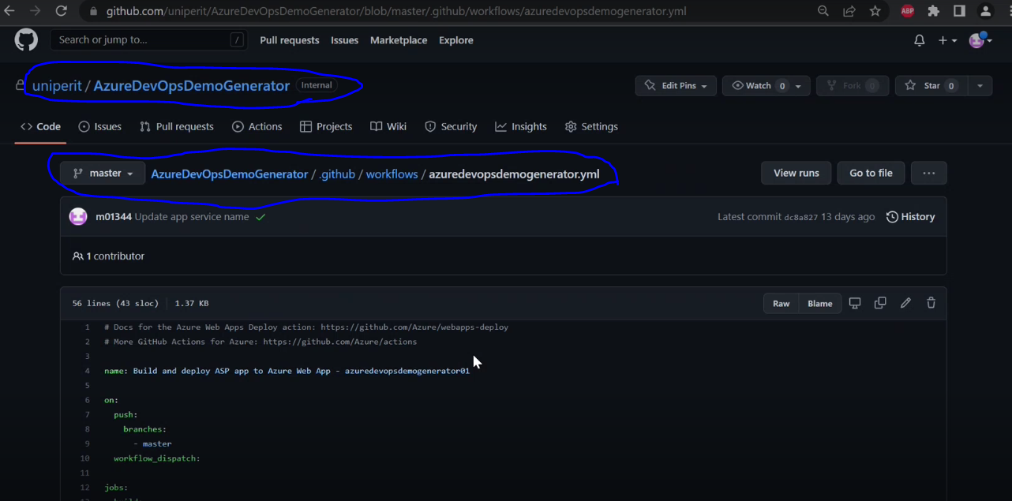

**34. Terminologies using in Github:**

**34.1 Events:**

* events will trigger that will execute the workflows. Which means if developer push their code into master branch, by the time workflow file will be triggered in the particular repository.
* once the github action triggered, we can see we can see the progress under Actions

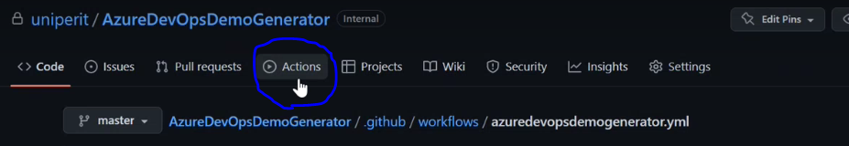

**34.2 Jobs:**

Jobs are sequence of steps that get execute inside a runner.

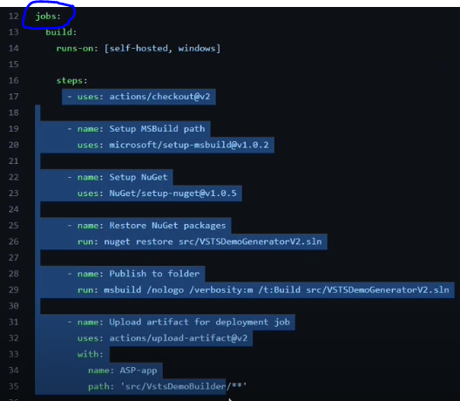

**34.3 Environment Variables:**

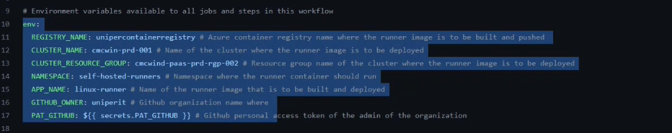

**35. Reference Links**

**Azure portal:**

<https://portal.azure.com>

**Azure DevOps Portal:**

<https://dev.azure.com/uniperteamservices/CMC%20Sprint%20Planning/_boards/board/t/Automation/Backlog%20items>

<https://dev.azure.com/uniperteamservices/>

**SNOW Access (ServiceNow):**

<https://apc01.safelinks.protection.outlook.com/?url=https%3A%2F%2Funiperprod.service-now.com%2Fnav_to.do%3Furi%3D%252Fchange_request.do%253Fsys_id%253Daf360b1b1bdecd10ce24859ee54bcbdd%2526sysparm_stack%253D%2526sysparm_view%253D&data=04%7C01%7CAtul.Potdar%40cognizant.com%7C5f059073f9bc46392dc808da0ce104eb%7Cde08c40719b9427d9fe8edf254300ca7%7C0%7C0%7C637836458169103417%7CUnknown%7CTWFpbGZsb3d8eyJWIjoiMC4wLjAwMDAiLCJQIjoiV2luMzIiLCJBTiI6Ik1haWwiLCJXVCI6Mn0%3D%7C3000&sdata=mzaoHLedwWxh56Fz4wDO0Pi0UDgYHSe2qUWVfBTfAyE%3D&reserved=0>

**Uniper WiKi, JIRA, and Uniper Confluence Login Pages (click on ::: and use to login):**

<https://wiki.intranet.uniper.energy/sales/display/CF/Hosting+Framework+Starting+Page>

**Azure Devops catalog:**

<https://wiki.intranet.uniper.energy/sales/display/CF/DevOps+-+Add-cancel+user+on+Azure+DevOps>

**Azure DevOps Service Now Catalogue:**

<https://uniperprod.service-now.com/unipersp?id=sc_category_uni&sys_id=8c10cf96db382c10d1ebbaf1f396192b>

**VDI connect:**

<https://rdweb.wvd.microsoft.com/arm/webclient/index.html>

<https://client.wvd.microsoft.com/arm/webclient/index.html>

**Sharepoint URL:**

[**https://uniper.sharepoint.com/sites/AzureDevOps/**](https://uniper.sharepoint.com/sites/AzureDevOps/)

**ServiceNow portal:**

<https://uniperprod.service-now.com/nav_to.do?uri=%2Fsc_task_list.do%3Fsysparm_first_row%3D1%26sysparm_query%3Dactive%253Dtrue%255Eassignment_group%253D2cc46039db89fc102ee0918cd3961930%255EORassignment_group%253D46ca81c8db3b7f444762f7871d9619b9%26sysparm_view%3D>

**Public Wiki Pages:**

<https://wiki.intranet.uniper.energy/sales/display/CF/Cloud+Development+Platform>

**login with Uniper ID:**

<https://cognizantonline.sharepoint.com/:x:/r/sites/UniperSECognizant/_layouts/15/Doc.aspx?sourcedoc=%7BED7AD038-327E-452C-9B27-BAB8E7BFD5F1%7D&file=Wiki%20Links%20Tracker.xlsx&action=default&mobileredirect=true&cid=e56019ee-d354-4f95-b307-ced654e13376>

**DevOps Service catalog forms:**

<https://uniperprod.service-now.com/unipersp?id=sc_category_uni&sys_id=8c10cf96db382c10d1ebbaf1f396192b>

**Azure Devops Shadowing sessions:**

* Usually, we will get the different kind of tickets through Service Now
* Mostly we get tickets like create project creation, create service principle, extensions

**Create a New project in Agile method:**

* Users will request to create a new project, and users will mention the Project name in SNOW ticket itself.
* Once we get ticket into our Team, have to Acknowledge first and change status.

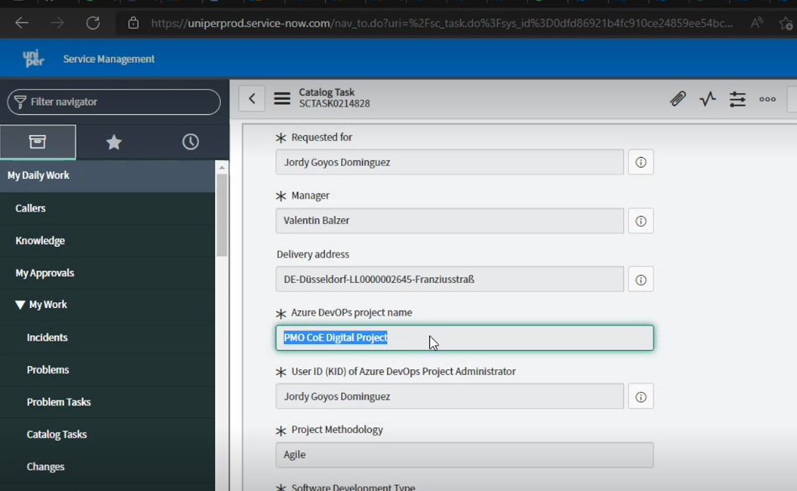

* To create new project, got to Azure Devops board and select new project

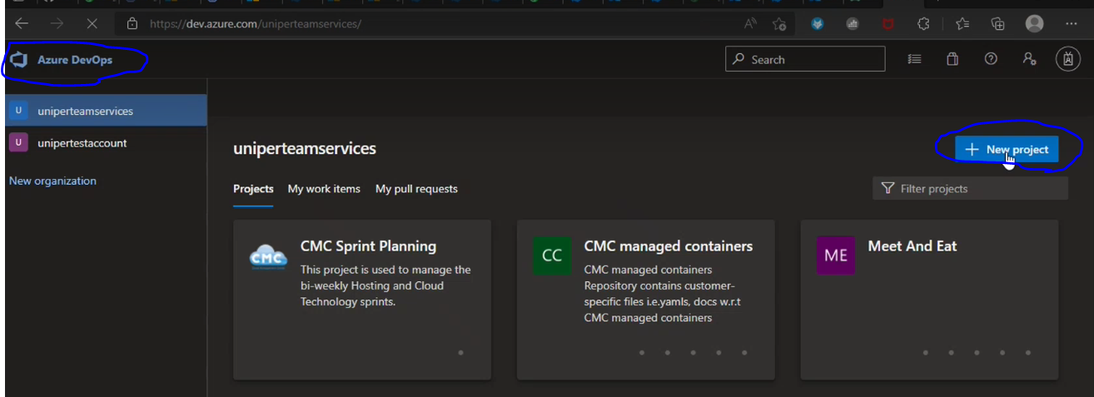

* Always select Visibility as Private and select Agile methodology in Advance (dropdown) and click on create.

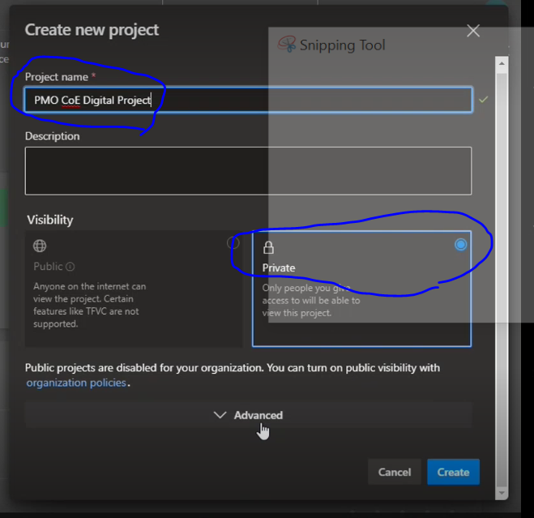

* Once created every project, go to project settings, and click on Add Administrator, search for [TEAM FOUNDATION]\AZ-CMC-DEV-TEAM and click on add.
* Which means who are the members in this group, they are all have the admin permission for this project.

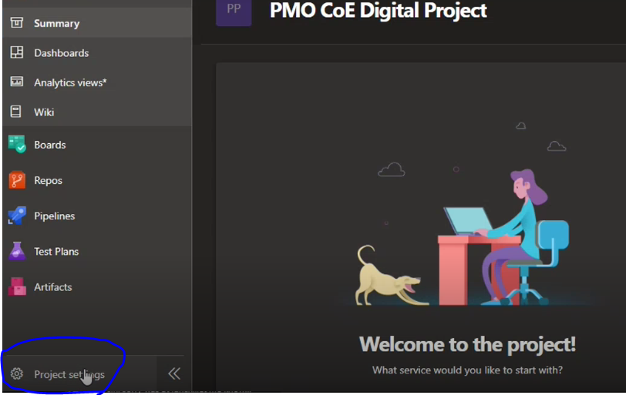

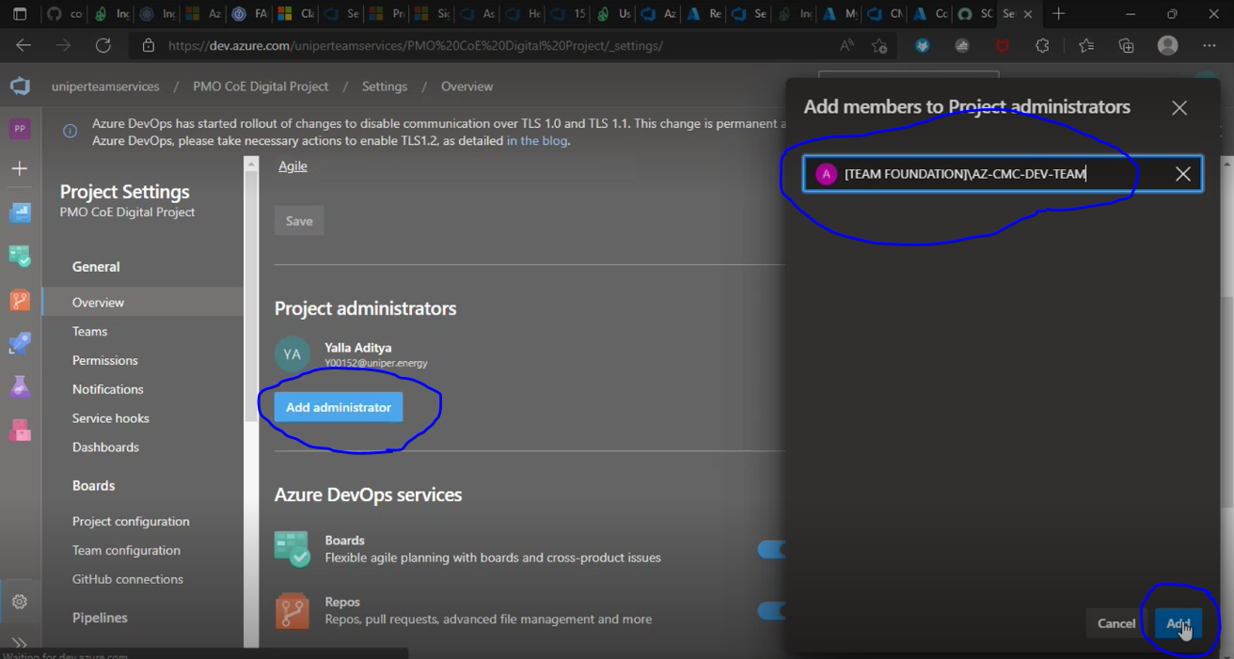

* Go to permission tab in Project settings, we must add HACT Operation Support group.
* Go to new group, give the name of the group, members and provide the description, and click on create.

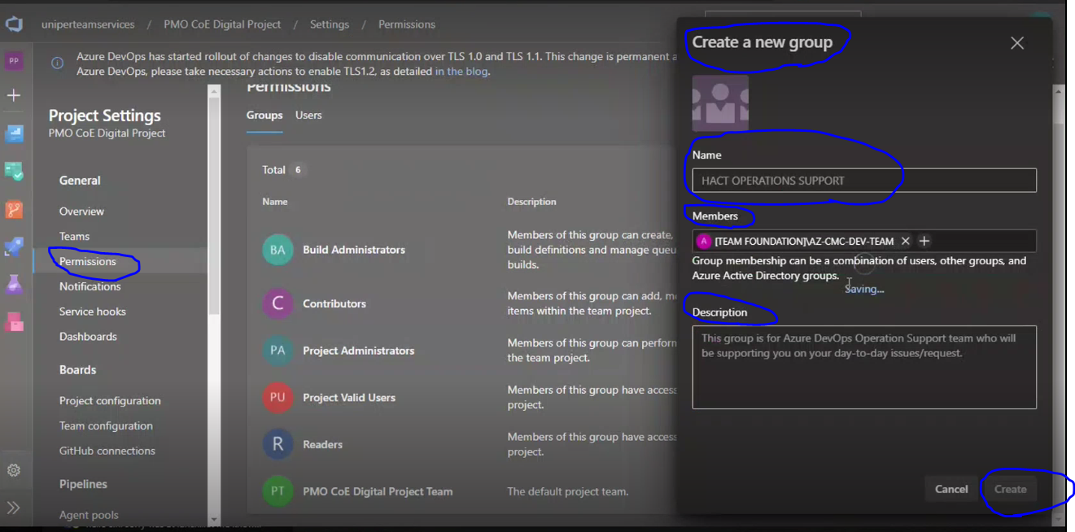

* Once we are into HACT OPERATION Support Group, in permission section we must customize the permission as Allow. It is mandatory and by default it is Denay.
* <https://cognizantonline-my.sharepoint.com/personal/885258_cognizant_com/Documents/Desktop/Uniper%20Project/Azure%20Devops/Set%20up%20new%20Azure%20DevOps%20project_.pdf>

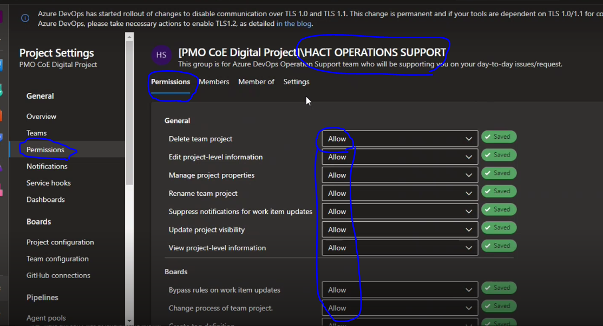

* Once we created project, go to the SNOW ticket in service now, and provide the created project URL in the comment section and user let know. then change the ticket status and save.
* NOTE: once let users know about the project been created, keep status as Awaiting, and if we put InProgress SLA time will be breach.

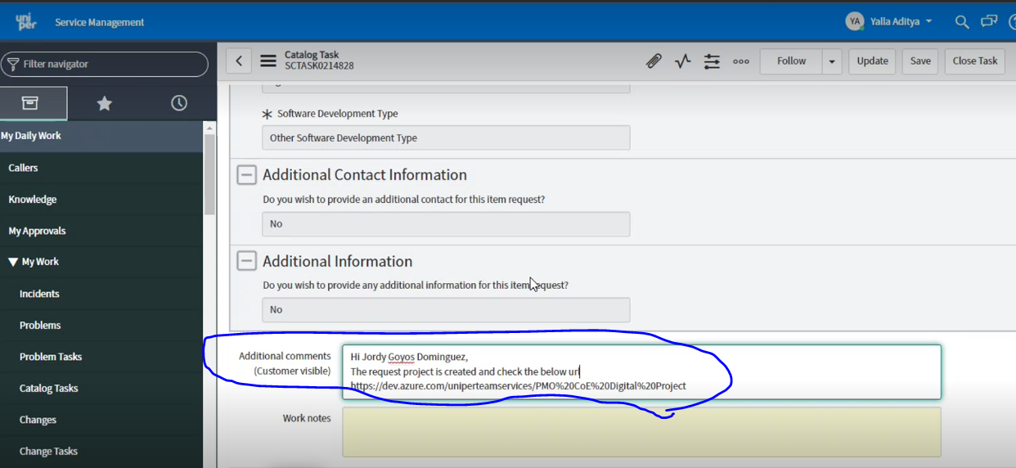

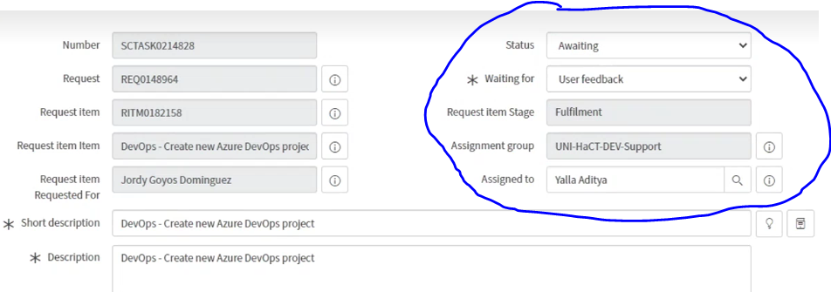

**Service connection creation for requested project: ex: project name is “Dynamic Dalsy – Streaming” and Resource Group:**

* Usually, DS team will create the Service connection.
* We have 2 ways to create Service connection, 1. let DS team let know 2. CMC portal
* Currently we are not using CMC portal to create Service connection due to Naming convention implementation is in progress.
* Once DS team create the service connection.
* Initially service principle created, we must check with IAM team to provide CMC pass contributor access.
* CMC pass contributor access can allow us to push, pull, access the Artifacts.etc to the particular resource group.
* Indumathi is the lead to provide CMC pass contributor access. For this usually we text her in teams.

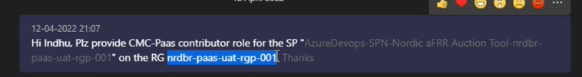

* Once we get CMC contributor access, then go to that project and go to Service connection and select Azure Resource Manager, then click next and select Service Principal(manual) and click next

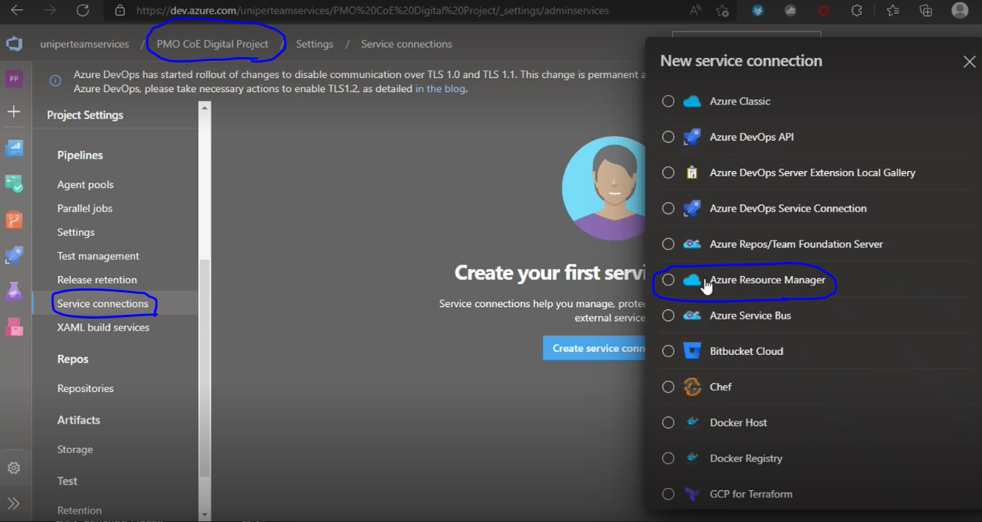

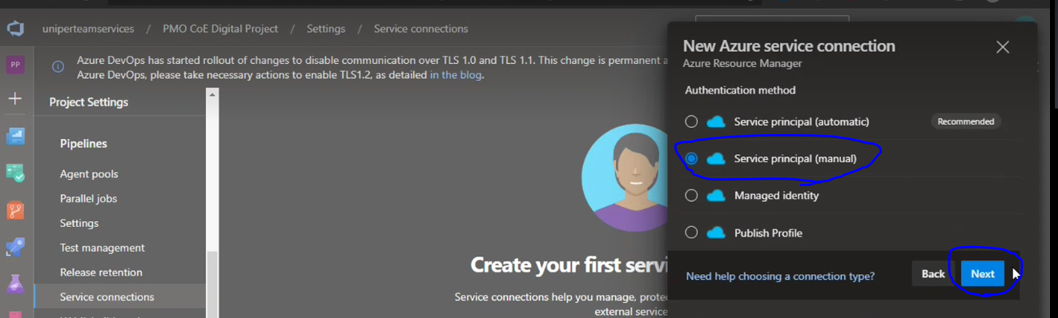

* And we have to provide Service principal ID, Key, Subscription name, ID of the resource group, Tenant ID and have to create secret and provide value, and then all the parameters passed click on verify I will show as Successful message.

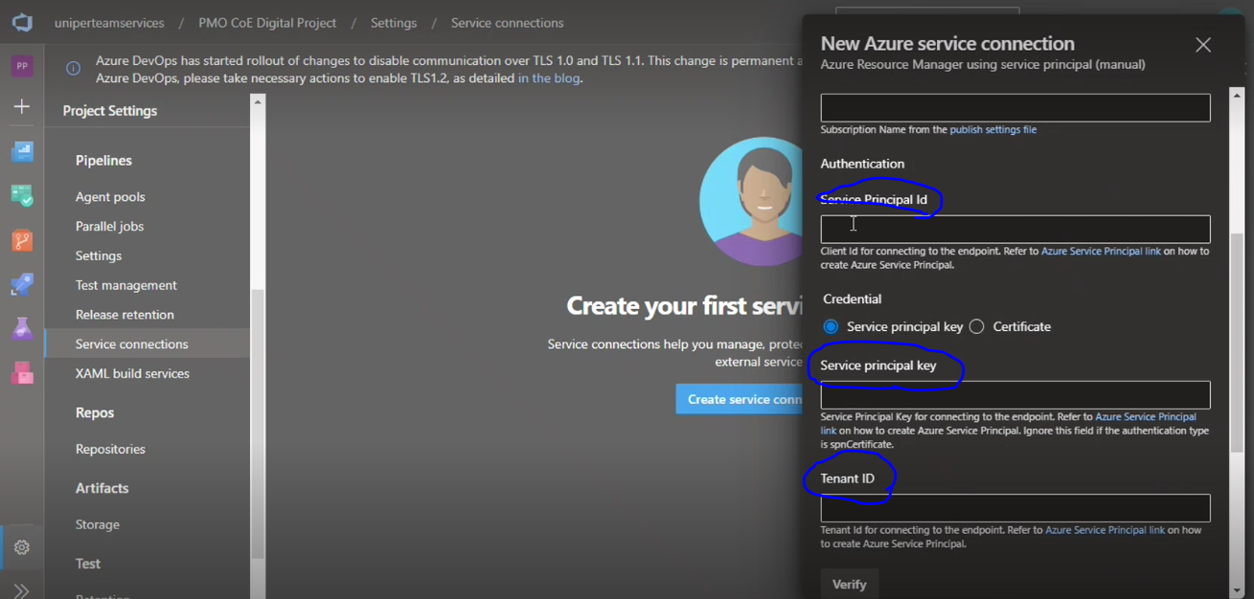

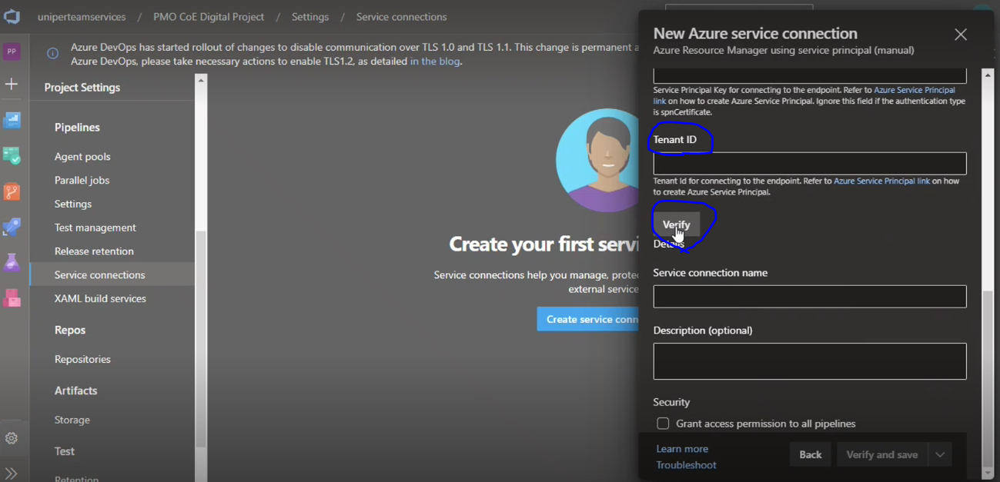

* In the Service connection name field, we should pass the user mentioned in service now tickets.
* Once done have to check the Security check box to Grant access permissions to all Pipelines.

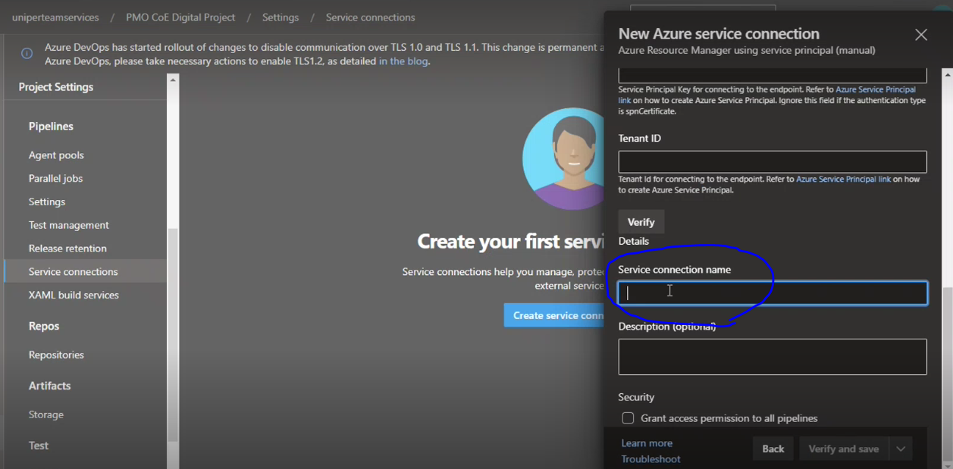

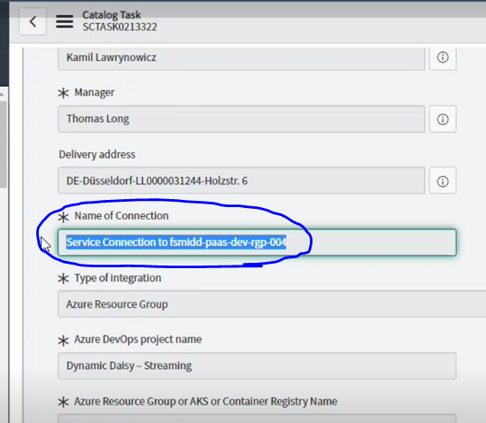

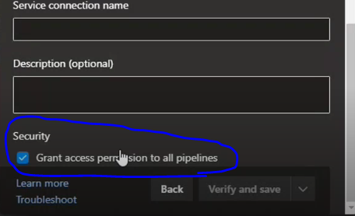

* Currently we have 670+ Service connections
* For every Service principal Client ID and tenant ID will be generated automatically.

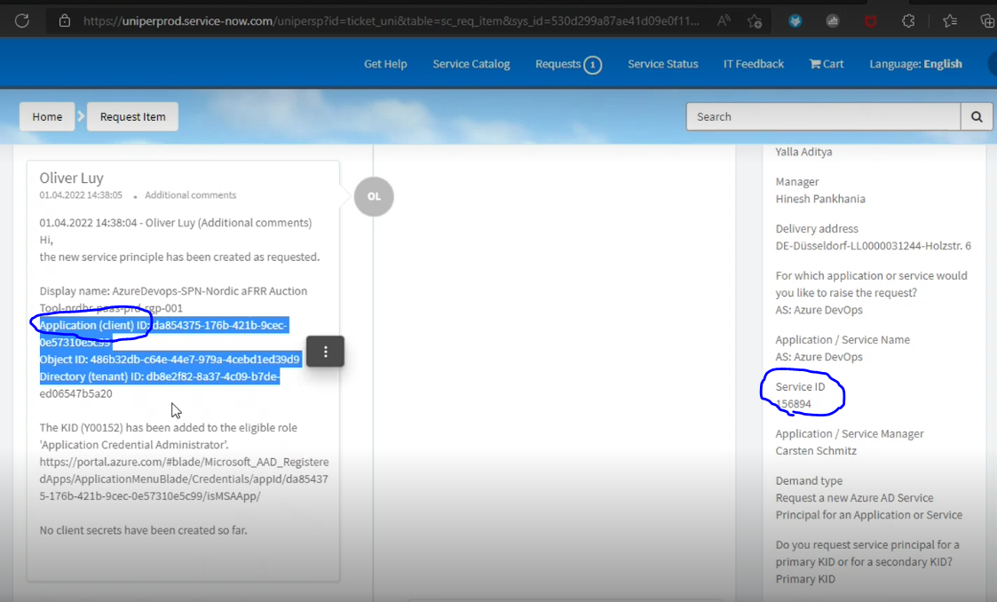

**Name Space creation for project:**

* Usually, infra team (Chandini) will request us to create Service connection.
* They provide the Name space, Cluster name and project name.

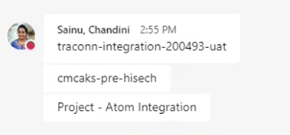

* We can see the cluster information, Go to All Services -> Kubernetes Services-> search for required cluster name and will get subscription ID , resource group… etc

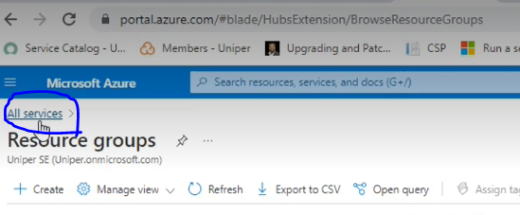

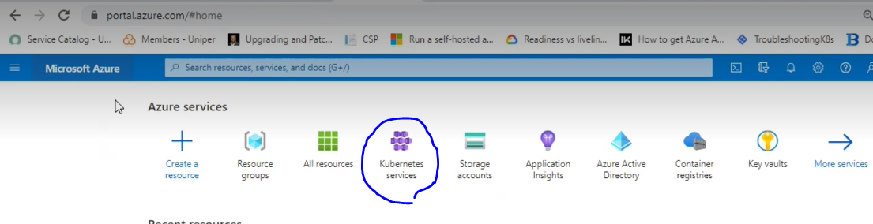

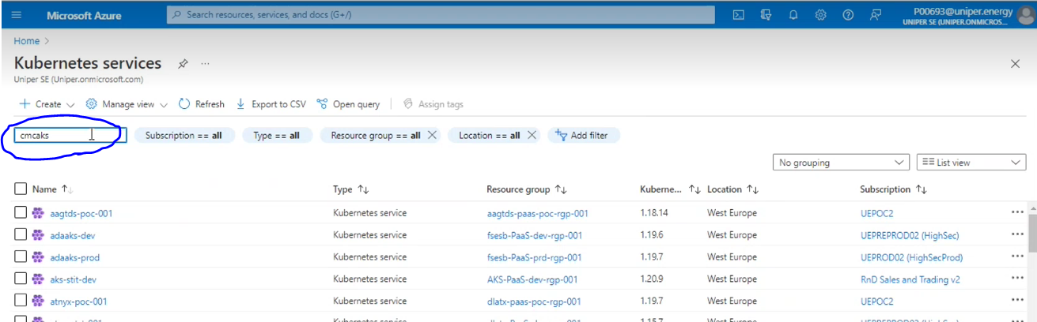

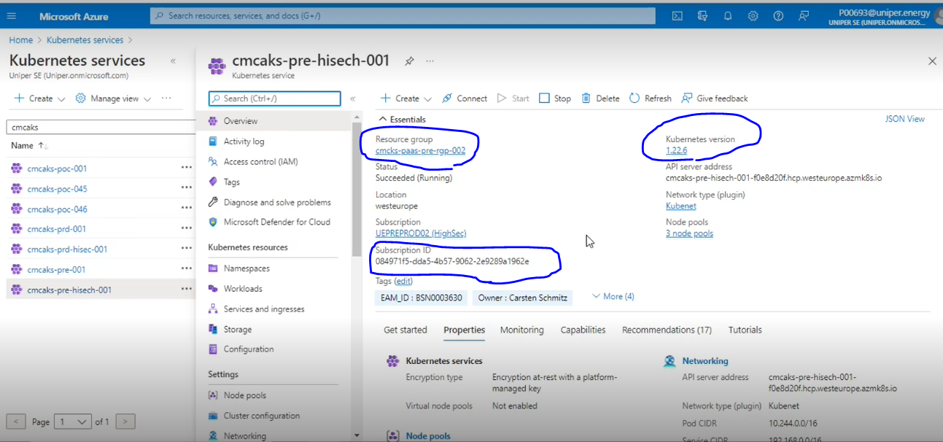

* Go to project settings ->Service connection, click on create Service connection and search for Kubernetes then click next

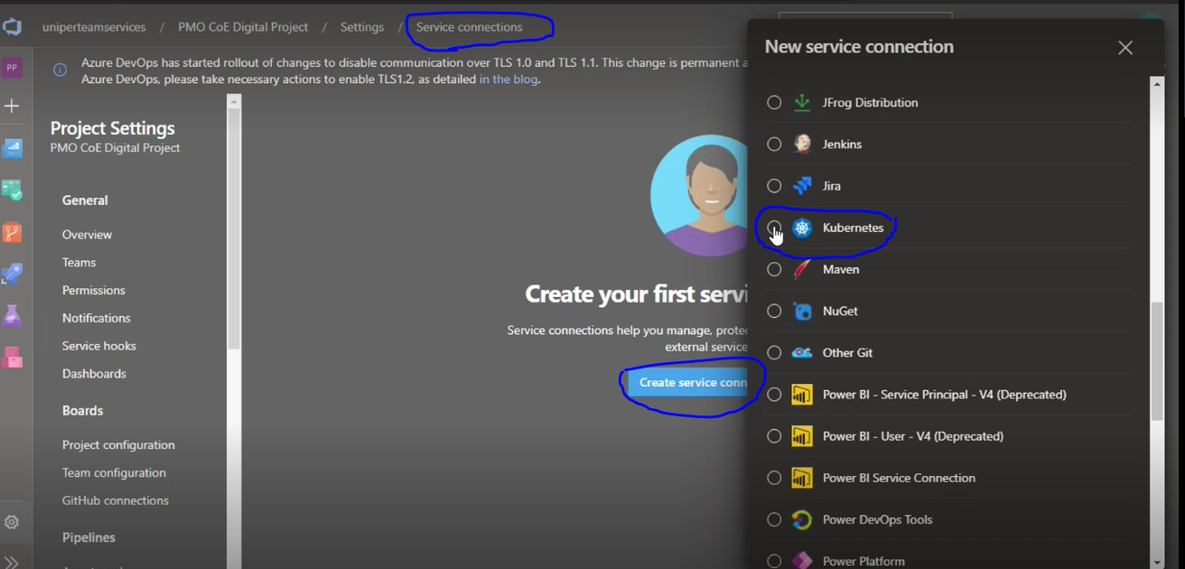

* Search for the new Kubernetes service connection and click on Azure subscription(cluster), cluster name and Namespace. and leave the below as it is.
* Give the namespace as meaning full for this namespace and check the Security check box as grant access permissions to all pipelines and click n save.

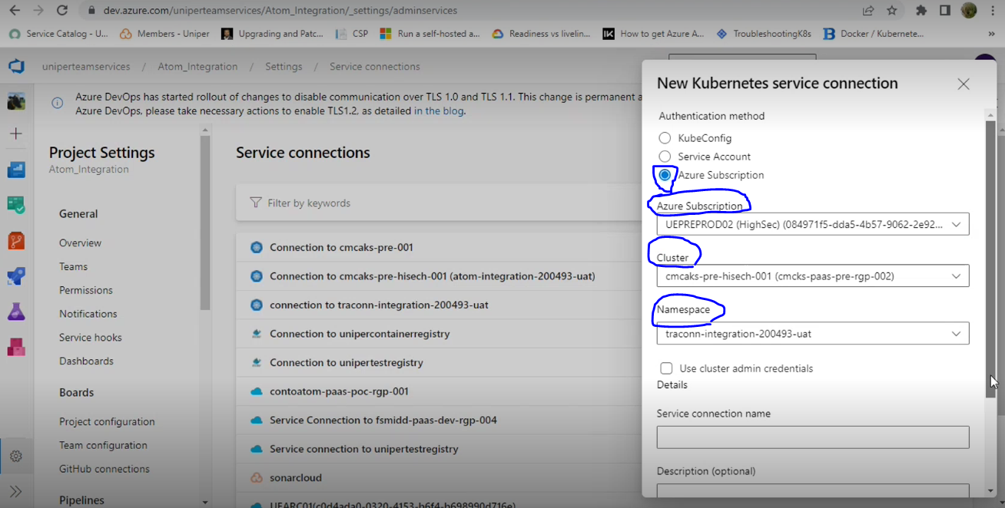

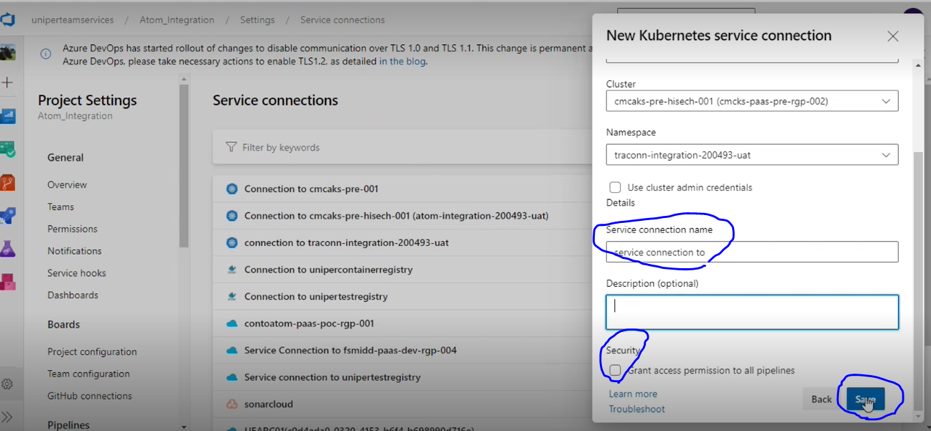

* Once we save it, can see this at

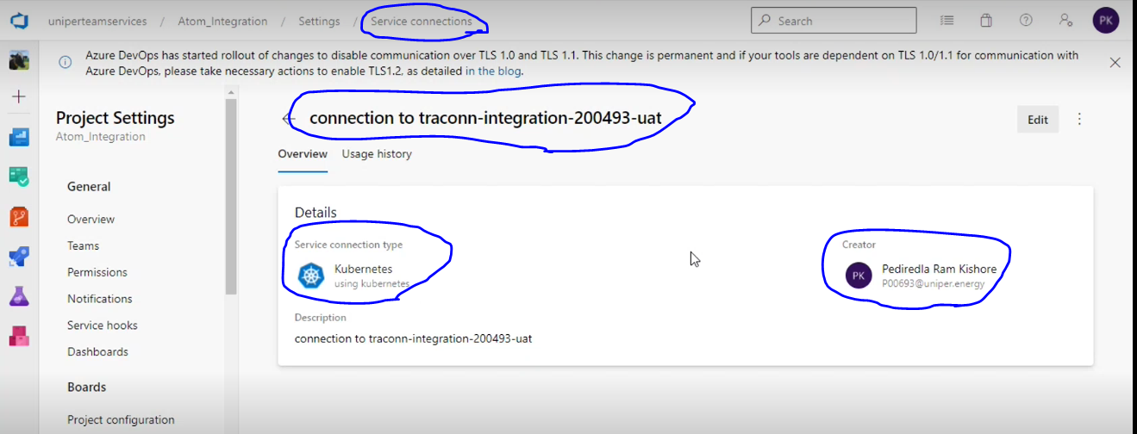

* Freaquently we will get 3 types of Service connections

1. NameSpace

2. Resource Group

3. Service Container Registry (SCR)

* Earlier we use to use Cloud Service Portal to create resource groups. But currently we are not using this portal.

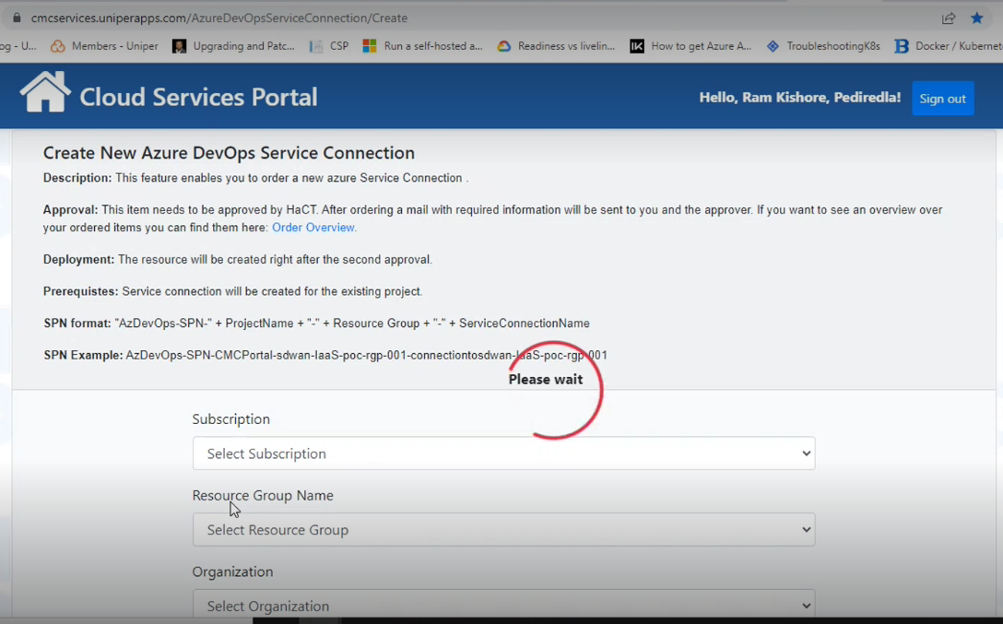

**Extensions:**

* Mostly Carsten will guide us to do from our team or Carsten will take care of it.